Algebra 2
1.2 Graph Quadratic Functions in Vertex and Intercept Form
Starter(s): Find the vertex and the axis of symmetry for each quadratic function:
1.$f\left(x\right)=x^{2}+6x+9$ 2. $g\left(x\right)=4x^{2}+7x-2$

------------------------------------------------------------------------NOTES-------------------------------------------------------------------------------
EXAMPLE 1: Graph a Quadratic in Vertex Form EXAMPLE 2 Use a Quadratic Model in Vertex Form
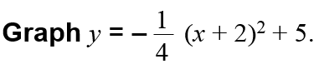
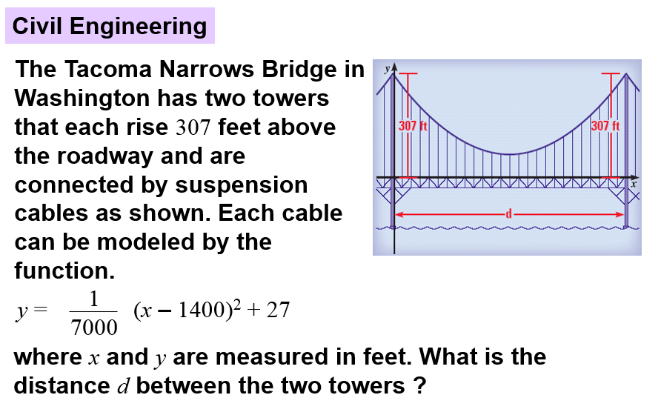

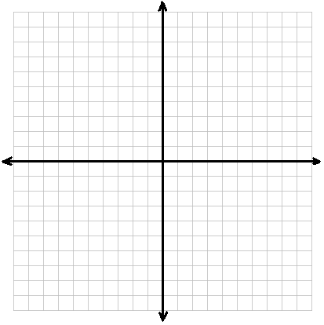

YOU TRY:
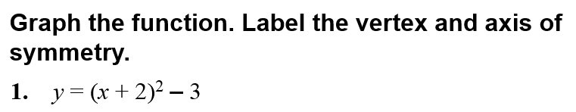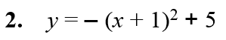

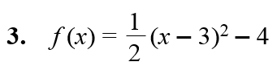
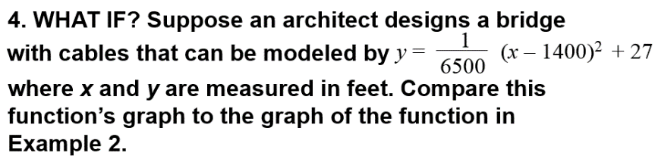

EXAMPLE 3 Graph a Quadratic Function in Intercept Form EXAMPLE 4 Use a Quadratic Function in Intercept Form
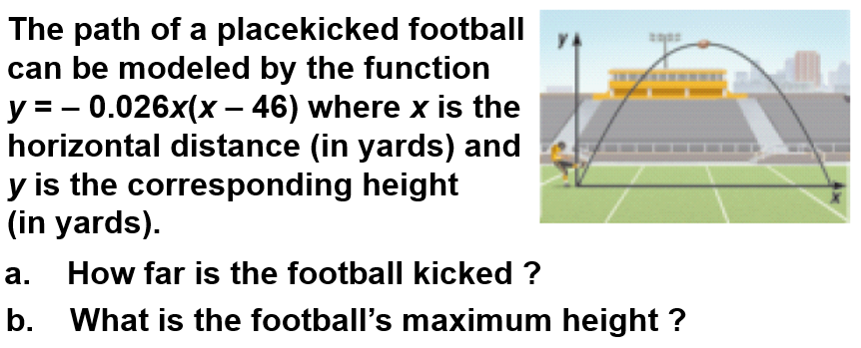

YOU TRY:
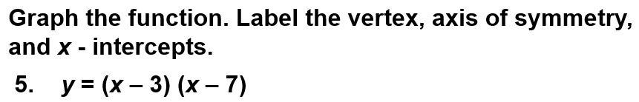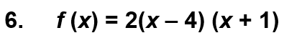

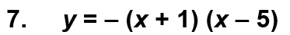 8. WHAT IF? In Example 4, what is the maximum height of the football if the football’s path can be modeled by the function y = – 0.025x(x – 50)?

EXAMPLE 5: Change from Intercept Form to Standard Form EXAMPLE 6: Change from Vertex Form to Standard Form

YOU TRY:
