Algebra 2 w/ Trig
1.3 Solving $x^{2}+bx+c=0$
Warm- Up:
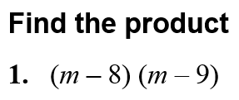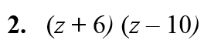

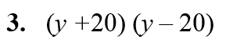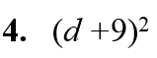

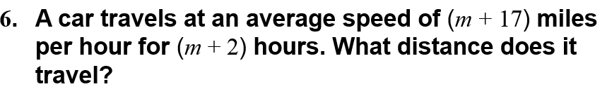
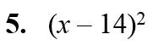

-------------------------------------------------------NOTES-----------------------------------------------------------------------------------
EXAMPLE 1: Factor Trinomials of the form $x^{2}+bx+c$
Factor the following expressions:
a. x² – 9x + 20 b. x² + 3x – 12

You Try:
1. x² – 3x – 18 2. n² – 3n + 9

EXAMPLE 2: Factor with Special Patterns
Factor the following expressions: YOU TRY:
a. x² – 49 3. x² – 9

b. d ² + 12d + 36 4. q² – 100

c. z² – 26z + 169 5. y² + 16y + 64

EXAMPLE 3: Finding the Roots of the Equation
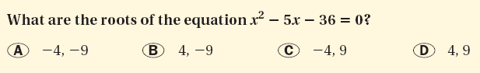

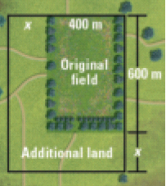
Example 4: Use a Quadratic Equation as a Model
A town has a nature preserve with a rectangular field that measures 600 meters by 400 meters. The town wants to double the area of the field by adding land as shown. Find the new dimensions of the field.

YOU TRY:
6. Solve the equation x² – x – 42 = 0. 7. What If ? In Example 4, suppose the field initially
measures 1000 meters by 300 meters. Find the new dimensions of the field.

EXAMPLE 5: Finding the Zeros of a Quadratic Function Using Intercept Form
Find the zeros of the function by rewriting the function in intercept form.
a. y = x² – x – 12 b. y = x² + 12x + 36

YOU TRY:
8. y = x² + 5x – 14 9. y = x² – 7x – 30

KEEP GOING!!
Factor the expression.
1. y² + 5y – 24
5. Find the zeros of f(x) = x² + 14x + 49.

6. The dimensions of a playground are 50 feet by 75 feet. You want to double its area by adding the same distance x to the length and width. Find x and the new dimensions of the playground.

2. z² – 225

3. 4w² – 20w + 25

4. Solve x² – 9x + 8 = 0

