Algebra 2 w/ Trig
1.4 Solving $ax^{2}+bx+c=0$
Warm- Up:
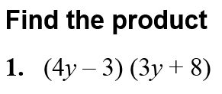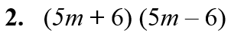

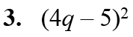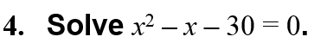

-------------------------------------------------------NOTES-----------------------------------------------------------------------------------
EXAMPLE 1: Factor a$x^{2}+bx+c$ where c>0 YOU TRY:
Factor 5x² – 17x + 6. Factor 1. 7x² – 20x – 3

EXAMPLE 2: Factor a$x^{2}+bx+c$ where c<0
Factor 3x² + 20x – 7. Factor 2. 5z² + 16z + 3

Factor 3. 2w² + w + 3

EXAMPLE 3: Factoring with Special Patterns
Factor the expression.
a. 9x² – 64 b. 4y² + 20y + 25 c. 36w² – 12w + 1

YOU TRY:
4. 16x² – 1 5. 9y² + 12y + 4 6. 4r² – 28r + 49

7. 25s² – 80s + 64 8. 49z² + 4z + 9 9. 36n² – 9

Example 4: Factor Out Monomials First
Factor the expression. YOU TRY:
a. 5x² – 45 10. 3s² – 24

b. 6q² – 14q + 8 11. 8t² + 38t – 10

c. – 5z² + 20z 12. 6x² + 24x + 15

d. 12p² – 21p + 3 13. 12x² – 28x – 24

14. – 16n² + 12n

EXAMPLE 5: Solving Quadratic Equations
Solve the following quadratic equation:
a. 3x² + 10x – 8 = 0 b. 5p² – 16p + 15 = 4p – 5.

YOU TRY:
Solve the following Quadratic Equations:
15. 6x² – 3x – 63 = 0 16. 12x² + 7x + 2 = x +8

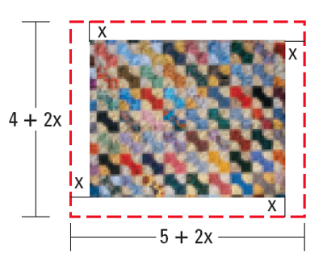
EXAMPLE 6: Use a Quadratic Equation as a Model
You have made a rectangular quilt that is 5 feet by 4 feet. You want to use the remaining 10 square feet of fabric to add a decorative border of uniform width to the quilt. What should the width of the quilt’s border be?

EXAMPLE 7: Solve a Multi-Step Problem
A monthly teen magazine has 28,000 subscribers when it charges $10 per annual subscription. For each $1 increase in price, the magazine loses about 2000 subscribers. How much should the magazine charge to maximize annual revenue? What is the maximum annual revenue?

KEEP GOING:
Hw: Section 1.3 p. 22 #25-37 odd & Section 1.4 p. 29 #33-39 odd
Factor the expression.
1. 8r² + 6r – 5

2. 3p² – 7p + 4

3. 5z² – 80

4. 9m² + 30mn + 25n²

5. Solve 5x² + x – 4 = 0.

6. A mat of uniform width and area 115 square inches
surrounds an 8-inch X 10-inch photograph. What is
the width of the mat?

