Algebra 2 w/ Trig
1.5 Solving Quadratics with Square Roots

Warm- Up:
Find the Exact Value.
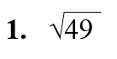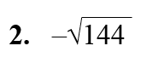

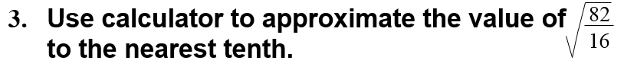

--------------------------------------------------------------------------NOTES----------------------------------------------------------------
Example 1: Simplify the Expression:
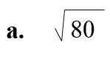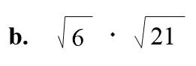

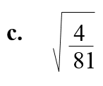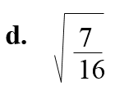

YOU TRY:
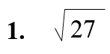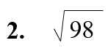

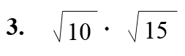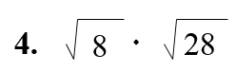

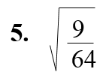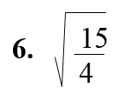

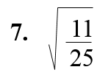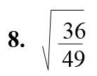

Example 2:
Simplify the following:
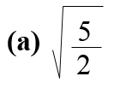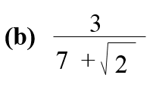

Example 3: Solve a Quadratic Equation.

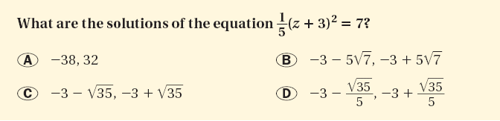

YOU TRY:
Simplify the expression.
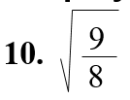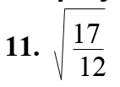

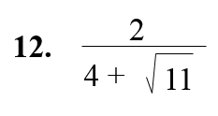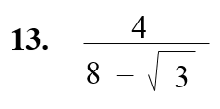

Solve the equation.
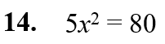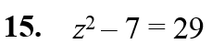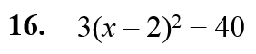

Example 5: Model a Dropped Object with a Quadratic Function
For a science competition, students must design a container that prevents an egg from breaking when dropped from a height of 50 feet. How long does the container take to hit the ground?

YOU TRY:
What If? In Example 5, suppose the egg container is dropped from a height of 30 feet. How long does the container take to hit the ground?

KEEP GOING:
Hw: Section 1.5 p. 35 #3-18 all
Simplify the Expression.
