Algebra 2 w/ Trig
1.6 Perform Operations with Complex Numbers
Warm-Up:
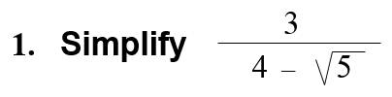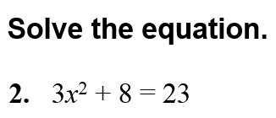

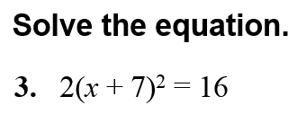

------------------------------------------------------------NOTES------------------------------------------------------------------------------
What is a complex number?____________________________________________________________________________________________________
The i wheel!
- $i^{8}$ b. $i^{39}$ c. $i^{111}$

Example 1: Solve a Quadratic Equation
Solve 2x² + 11 = –37.

YOU TRY: 1. x² = –13 2. x² = –38 3. x² + 11= 3

4. x² – 8 = –36 5. 3x² – 7 = –31 6. 5x² + 33 = 3

Example 2: Add and Subtract Complex Numbers
Write the expression as a complex number in standard form.
a. (8 – i) + (5 + 4i) b. (7 – 6i) – (3 – 6i) c. 10 – (6 + 7i) + 4i

YOU TRY:
Write the expression as a complex number in standard form.
7. (9 – i) + (– 6 + 7i) 8. (3 + 7i) – (8 – 2i) 9. – 4 – (1 + i) – (5 + 9i)

Example 3: Using Addition of Complex Numbers in Real Life
Circuit components such as resistors, inductors, and capacitors all oppose the flow of current. This opposition is called resistance for resistors and reactance for inductors and capacitors. A circuit’s total opposition to current flow is impedance. All of these quantities are measured in ohms ( ).
Ω
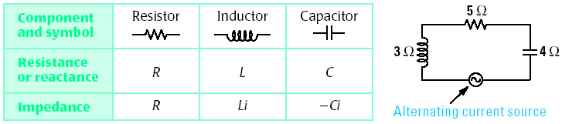
The table shows the relationship between a component’s resistance or reactance and its contribution to impedance. A series circuit is also shown with the resistance or reactance of each component labeled.
The impedance for a series circuit is the sum of the impedances for the individual components. Find the impedance of the circuit shown above.

Example 4: Multiply Complex Numbers
Write the expression as a complex number in standard form.
a. 4i(–6 + i) b. (9 – 2i)(–4 + 7i)

Example 5: Divide Complex Numbers
Write the quotient in standard form.
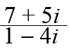

YOU TRY:
10. WHAT IF? In Example 3, what is the impedance of the circuit if the given capacitor is replaced with one having a reactance of 7 ohms?

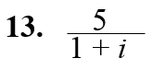
11. i(9 – i) 12. (3 + i) (5 – i)

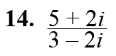

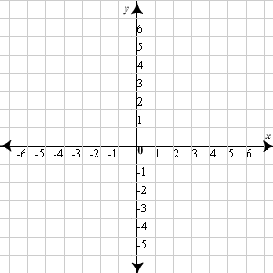
Example 6: Plot Complex Numbers
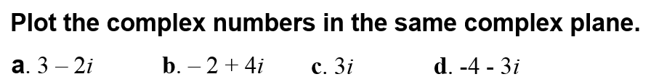

Example 7: Find the Absolute Value of Complex Numbers
a. |– 4 + 3i | b. |– 3i |

YOU TRY:
Plot the complex numbers in the same complex plane and find the absolute value.
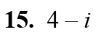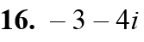

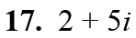

KEEP GOING:
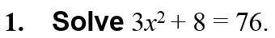

Evaluate each expression if X = 5 – 8i and Y = –9 + 3i. Write your answer as a complex number in standard form.
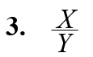
2. X – Y 4. X + Y

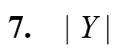
5. $X∙Y$ 6. 6Y

