Algebra 2 w/ Trig
1.7 Complete the Square
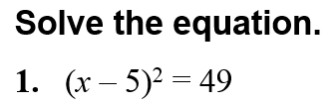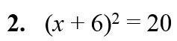

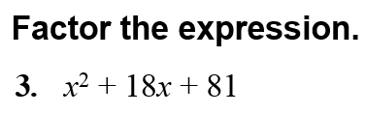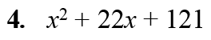

--------------------------------------------------------NOTES----------------------------------------------------------------------------------
Example 1: Solve a Quadratic Equation by Finding Square Roots
Solve x² – 8x + 16 = 25.

Example 2: Make a Perfect Square Trinomial
Find the value of c that makes x² + 16x + c a perfect square trinomial. Then write the expression as the square of a binomial.

YOU TRY:
Solve the equation by finding square roots.
1. x² + 6x + 9 = 36. 2. x² – 10x + 25 = 1. 3. x² – 24x + 144 = 100.

Find the value of c that makes the expression a perfect square trinomial. Then write the expression as the square of a binomial.
4. x² + 14x + c 5. x² + 22x + c 6. x² – 9x + c

Example 3: Solve ax² + bx + c = 0 when a = 1 Example 4: Solve ax² + bx + c = 0 when a $≠$ 1
Solve x² – 12x + 4 = 0 by completing the square. Solve 2x² + 8x + 14 = 0 by completing the square.

Example 5: Multiple Choice!!!
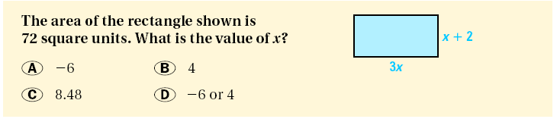

YOU TRY:
7. Solve x² + 6x + 4 = 0 by completing the square. 8. Solve x² – 10x + 8 = 0 by completing the square.

9. Solve 2n² – 4n – 14 = 0 by completing the square. 10. Solve 3x² + 12n – 18 = 0 by completing the square.

11. 6x(x + 8) = 12 12. 4p(p – 2) = 100

Example 6: Write a Quadratic Function in Vertex Form
Write y = x² – 10x + 22 in vertex form. Then identify the vertex.

Example 7: Find the maximum value of a quadratic function.
The height y (in feet) of a baseball t seconds after it is hit is given by this function:
y = –16t² + 96t + 3

YOU TRY:
13. Write y = x² – 8x + 17 in vertex form. 14. Write y = x² + 6x + 3 in vertex form.
Then identify the vertex. Then identify the vertex.

15. What if ? In example 7, suppose the height of the baseball is given by y = – 16t² + 80t + 2. Find the maximum height of the baseball.

