Algebra 2 w/ Trig
1.8 Quadratic Formula and Discriminant
Warm- Up:

-----------------------------------------------------------NOTES-------------------------------------------------------------------------------
Example 1: Solve an Equation with Two Real Solutions Example 2: Solve an Equation with One Real Solution
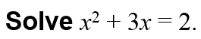

Example 3: Solve an Equation with Imaginary Solutions
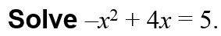

YOU TRY:
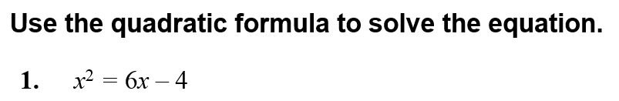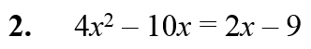

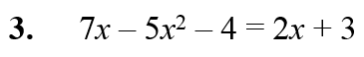

Example 4: Use the Discriminant
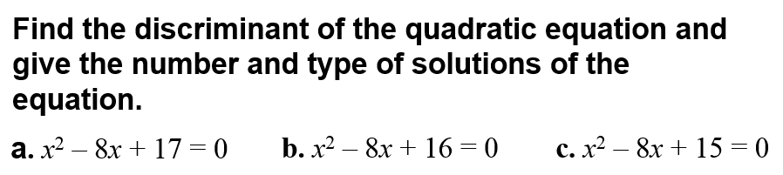

YOU TRY:
Find the discriminant of the quadratic equation and give the number and type of solutions of the equation.
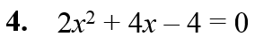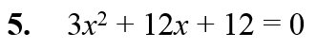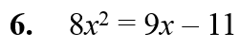

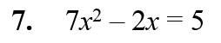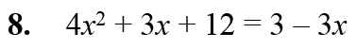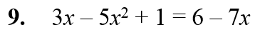

Example 5: Solve a Vertical Motion Problem
A juggler tosses a ball into the air. The ball leaves the juggler’s hand 4 feet above the ground and has an initial vertical velocity of 40 feet per second. The juggler catches the ball when it falls back to a height of 3 feet. How long is the ball in the air?
HINT: Use h = –16t² + v₀t + h₀.

YOU TRY:
What If? In Example 5, suppose the ball leaves the juggler’s hand with an initial vertical velocity of 50 feet per second. How long is the ball in the air?

KEEP GOING:
Use the quadratic formula to solve the equation.
1. 4x² – 4x + 1 = 0 2. – x² + 8x = 20 3. – x² = 6x – 2

5. An object is thrown upward from a height of 15 feet at an initial velocity of 35 feet per second. How long will it take for the object to hit the ground?

4. Find the discriminant of 2x² + 3x – 6 = 0 and give
the number and type of solutions of the equation.

Hw: Section 1.8 p. 62 #13-39 odd

