1.9 Patterns Equations and Graphs
Starter:

Vocab:
Solution of an Equation (with two variables):
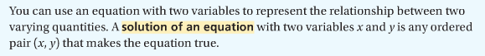

Identifying solutions of a two variable equation:
Is (3,10) a solution of the equation y = 4x ?

a.

b.

c.

d

Word Problem:
Both Carrie and her sister Kim were born on October 25, but Kim was born 2 yrs before Carrie. How can you represent the relationship between Carrie’s age and Kim’s age in different ways?
Step 1: Make a Table

Step 2: Write an equation

Step 3: Draw a Graph

Give it a shot:
Will runs 6 laps before Megan joins him at the track. They then run together at the same pace. How can you represent the relationship between the number of labs Will runs and the number of laps Megan runs in different ways? Use a table, an equation, and a graph.

Inductive reasoning:

Extending a Pattern:
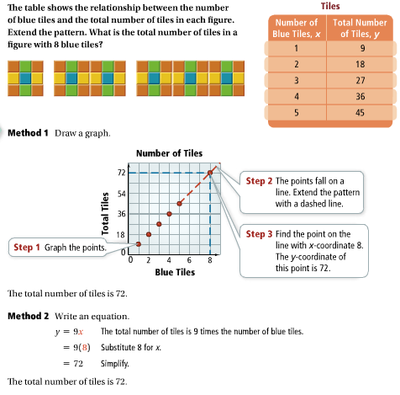

3. Using the figure in the previous Problem:
a. Make a table showing the number of orange tiles and the total number of tiles in each figure. How many tiles in all will be in figure with 24 orange tiles?

b. Make a table showing the number of blue tiles and the number of yellow tiles in each figure. How many yellow tiles will be in a figure with 24 blue tiles?

HW:
Pg 64 #8-15odd, 21-24, 32

