Algebra 2 w/ Trig
10.1 Graph Sine and Cosine Functions
Warm-Up:
Find the sine, cosine, and tangent.
- $\frac{π}{2}$ 2. $2π$

- The diameter of a wheel is 27 inches. Through how many radians does a point on the wheel move when the wheel moves 15 feet?

---------------------------------------------------------------NOTES----------------------------------------------------------------------------------------
Example 1: Graph Sine and Cosine Functions
Graph (a) $y = 4 sin x$ (b) $y = cos 4x$
Amplitude: Amplitude:
Period: Period:
Intercepts: Intercepts:
Maximum: Maximum:
Minimum: Minimum:
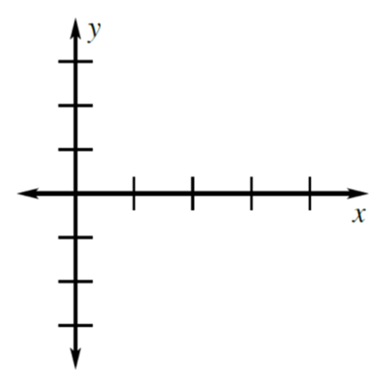

YOU TRY: Graph the function.
1. $y = 2 cos x$ 2. $y = 5 sin x$
Amplitude: Amplitude:
Period: Period:
Intercepts: Intercepts:
Maximum: Maximum:
Minimum: Minimum:
3. $f (x) = sin πx$ 4. $g(x) = cos 4πx$
Amplitude: Amplitude:
Period: Period:
Intercepts: Intercepts:
Maximum: Maximum:
Minimum: Minimum:
Example 2: Graph a Cosine Function
Graph $y=\frac{1}{2}cos2πx$
Amplitude:
Period:
Intercepts:
Maximum:
Minimum:

Example 3: Model with a Sine Function
A sound consisting of a single frequency is called a pure tone. An audiometer produces pure tones to test a person’s auditory functions. Suppose an audiometer produces a pure tone with a frequency f of 2000 hertz (cycles per second). The maximum pressure P produced from the pure tone is 2 millipascals. Write and graph a sine model that gives the pressure P as a function of the time t (in seconds).
Amplitude:
Period:
Intercepts:
Maximum:
Minimum:

YOU TRY: Graph the function.
$5. y=\frac{1}{4}sinπx$ 6. $y=\frac{1}{3}cosπx$
Amplitude: Amplitude:
Period: Period:
Intercepts: Intercepts:
Maximum: Maximum:
Minimum: Minimum:
7. $f (x) = 2 sin 3x$ 8. $g(x) = 3 cos 4x$
Amplitude: Amplitude:
Period: Period:
Intercepts: Intercepts:
Maximum: Maximum:
Minimum: Minimum:
9. What If ? In Example 3, how would the function change if the audiometer produced a pure tone with a frequency of 1000 hertz?
Hw: Section 10.1 p. 616 #3-23 odds

