Algebra 2/ with Trig
10.2 Translate and Reflect Trigonometric Graphs
Warm-Up:
Describe the translation of the graph of y = x² that produces the graph of the given function.
1. $y = x^{2} + 2$ 2. $y = x^{2} – 5$

3. $y = {\left(x – 1\right)}^{2}$ 4. $y = {\left(x + 3\right)}^{2}+ 4$

--------------------------------------------------------------NOTES-----------------------------------------------------------------------------------------
Example 1: Graph a Vertical Translation Example 2: Graph a Horizontal Translation
Graph $y = 2 sin 4x + 3$. Graph $y = 5 cos 2(x – 3π ).$
Amplitude: Amplitude:
Period: Period:
Horizontal Shift: Vertical Shift: Horizontal Shift: Vertical Shift:
Five Key Points on $y=k$: Five Key Points on $y=k$:
Maximum: Maximum:
Minimum: Minimum:

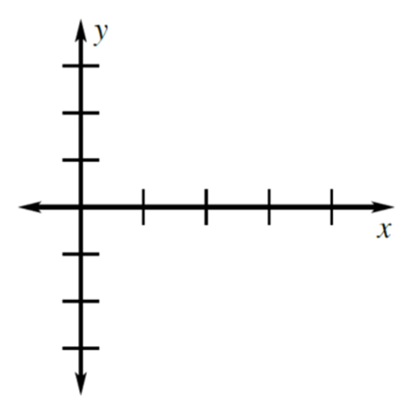

Example 3: Graph a Model for Circular Motion
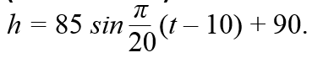
Suppose you are riding a Ferris wheel that turns for 180 seconds. Your height h (in feet) above the ground at any time t (in seconds) can be modeled by the equation
- Graph your height above the ground as a function of time.

b. What are your maximum and minimum heights?

YOU TRY: Graph the function.
- $y = cos x + 4.$ 2. $y=3sin(x-\frac{π}{2})$
Amplitude: Amplitude:
Period: Period:
Horizontal Shift: Vertical Shift: Horizontal Shift: Vertical Shift:
Five Key Points on $y=k$: Five Key Points on $y=k$:
Maximum: Maximum:
Minimum: Minimum:

YOU TRY: Example 4: Combine a Translation and Reflection
3. $f(x) sin (x + π) – 1$ $y=-2sin\frac{2}{3}(x-\frac{π}{2})$
Amplitude: Amplitude:
Period: Period:
Horizontal Shift: Vertical Shift: Horizontal Shift: Vertical Shift:
Five Key Points on $y=k$: Five Key Points on $y=k$:
Maximum: Maximum:
Minimum: Minimum:

YOU TRY: Graph the function.
4. $y=-cos⁡(x+\frac{π}{2})$ 5. $y=-3sin\frac{1}{2}x+2$
Amplitude: Amplitude:
Period: Period:
Horizontal Shift: Vertical Shift: Horizontal Shift: Vertical Shift:
Five Key Points on $y=k$: Five Key Points on $y=k$:
Maximum: Maximum:
Minimum: Minimum:

KEEP GOING:
- The depth d (in feet) of a boat’s propeller after t seconds can be modeled by a function that represents the graph of
$$d=7cos⁡(\frac{550}{3}πt)$$
translated up 24 units then reflected in the line y = 24. Write an equation for the model and graph the model.

- A drawbridge spans 150 feet. When the bridge is fully open, each section rises 43 feet from the horizontal. Write a model that gives the distance d (in feet) of each section from its highest point as a function of the angle of elevation.
Hw: Section 10.2 p.623 #3-31 every other odd

