Topic: ______________________________________________________________ Date: _____________________
Starter Problems:
(1.) Simplify: $\sqrt[4]{80a^{38}b^{9}}$ (2.) Simplify: $\sqrt[5]{2048c^{7}d^{23}}$

Review:
We can only __________________ or __________________ radical expressions that have ____________
____________________________ under the radical sign, so we may need to __________________ first!

Examples:
1.) $5\sqrt{3} + 2\sqrt{3}$ 2.) $7\sqrt{2} - \sqrt{2}$

_____________________________________________________________________________________________________
3.) $6\sqrt{5} + \sqrt{80}$ 4.) $\sqrt{24} - 3\sqrt{6}$

_____________________________________________________________________________________________________
5.) $4\sqrt{63} + \sqrt{567}$ 6.)$7\sqrt{108} + 2\sqrt{75}$

_____________________________________________________________________________________________________
7.) $3\sqrt{250} - 8\sqrt{90}$ 8.) $4\sqrt{180} - 11\sqrt{54}$

9.) $2\sqrt{147} + 6\sqrt{20} - 5\sqrt{192}$

_____________________________________________________________________________________________________
10.) $6\sqrt[3]{54} + 4\sqrt[3]{128}$

_____________________________________________________________________________________________________
11.) $7\sqrt[3]{24} - \sqrt[3]{375}$

_____________________________________________________________________________________________________
12.) $\sqrt[4]{324} + \sqrt[4]{64}$

_____________________________________________________________________________________________________
Review:
We can _________________ any two radical expressions together regardless of whether they have ____________________________ under the radical sign, but we may have to _________________ after we have multiplied!
Examples:
1.) $\sqrt{6} • \sqrt{15}$ 2.) $4\sqrt{10} • 3\sqrt{5}$

3.) $\sqrt{6} \left(2\sqrt{7} + 5\sqrt{8}\right)$ 4.) $\sqrt{2} \left(4\sqrt{10} - \sqrt{30}\right)$

_____________________________________________________________________________________________________
5.) $\left(\sqrt{3} + 7\right)\left(8\sqrt{3} + 4\right)$ 6.) $\left(7\sqrt{2} - 9\right)\left(3\sqrt{2} + 5\right)$

_____________________________________________________________________________________________________
Note:
We can also multiply two radical expressions that contain variables as long as we remember to ________________ their exponents.
7.) $\sqrt{15a^{5}b^{9}} • \sqrt{20ab^{6}}$

_____________________________________________________________________________________________________
8.) $\sqrt[3]{30m^{7}n^{2}} • \sqrt[3]{4m^{12}n}$

_____________________________________________________________________________________________________
Review:
In a division problem, instead of dividing the top by the bottom, we use a technique called
___________________________________________ in order to ensure that the final answer does not have a
____________________ sign in the ___________________.

Rule #1:
If the bottom is in the form _____________ then multiply the top and bottom by _____________.
Examples: Simplify:
1.) $\sqrt{\frac{16}{3}}$ 2.) $\sqrt{\frac{5}{8}}$

_____________________________________________________________________________________________________
3.) $\sqrt{\frac{x^{5}}{y^{7}}}$ 4.) $\sqrt{\frac{{9m}^{10}}{20n^{3}}}$

_____________________________________________________________________________________________________
Rule #2:
If the bottom is in the form ___________________________ then multiply the top and bottom by
___________________________ (called its _______________________).
_____________________________________________________________________________________________________
5.) $\frac{3}{\sqrt{2} + 5}$ 6.) $\frac{\sqrt{7} + 4}{6 - 2\sqrt{5}}$

_____________________________________________________________________________________________________
7.) $\frac{9}{4\sqrt{3} + 5\sqrt{6}}$

Homework: Adding/Subtracting/Multiplying and Dividing Radicals
Directions: Simplify each radical expression as much as possible.
1.) $5\sqrt{243} + \sqrt{675}$ 2.) $6\sqrt{175} - 10\sqrt{448}$

_____________________________________________________________________________________________________
3.) $\sqrt{245} + \sqrt{500} - \sqrt{1280}$ 4.) $\sqrt[3]{1080} + \sqrt[3]{384}$

_____________________________________________________________________________________________________
5.) $8\sqrt{3} • \sqrt{10} • 5\sqrt{2}$ 6.) ${\left(4\sqrt{5} \right)}^{2}$

7.) $\left(2\sqrt{7} - 6\right)\left(3 - \sqrt{7}\right)$ 8.) $\sqrt{24x^{7}y^{6}} • \sqrt{2x^{3}y^{11}}$

_____________________________________________________________________________________________________
9.) $\sqrt{\frac{6}{5}}$ 10.) $\sqrt{\frac{2}{3}}$

_____________________________________________________________________________________________________
11.) $\sqrt{\frac{x^{8}}{y^{5}}}$ 12.) $\frac{4\sqrt{5}}{6\sqrt{2} - \sqrt{3}}$

_____________________________________________________________________________________________________
EXTRA PRACTICE: Operations with Radical Expressions
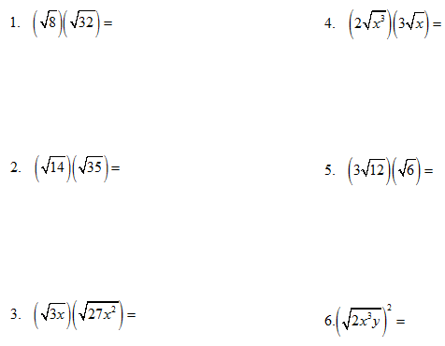

EXTRA PRACTICE: Operations with Radical Expressions
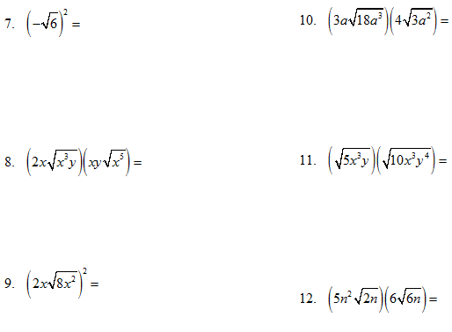

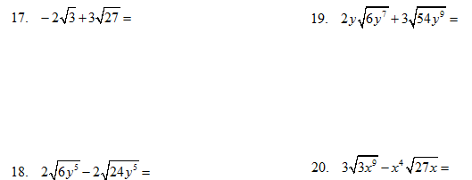

EXTRA PRACTICE: Operations with Radical Expressions
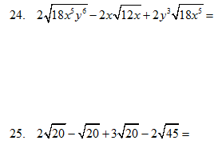
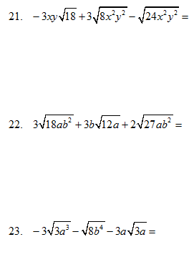

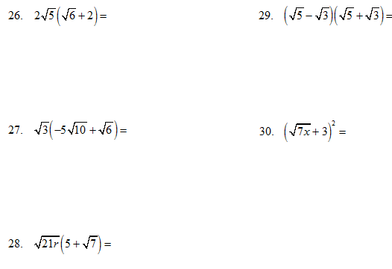

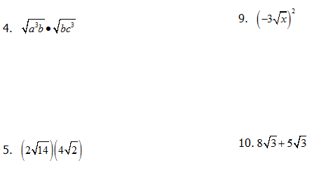
EXTRA PRACTICE: Operations with Radical Expressions

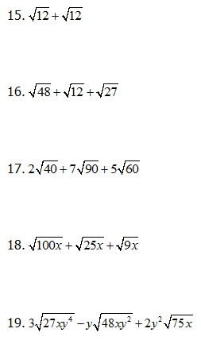
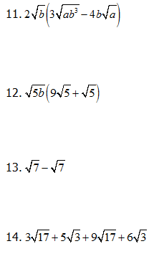

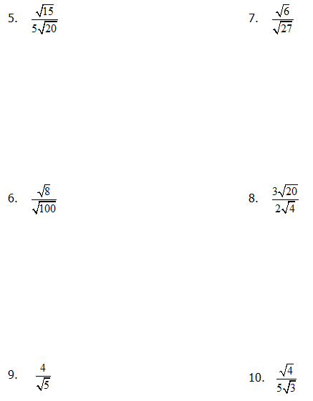
EXTRA PRACTICE: Operations with Radical Expressions

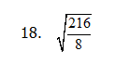
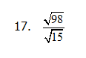

EXTRA PRACTICE: Operations with Radical Expressions

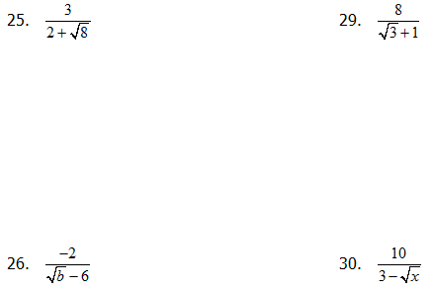

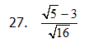
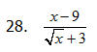

REVIEW: With Radical Expressions
1.) Simplify: $\sqrt[5]{3072m^{21}n^{8}}$ 2.) Un-simplify: $5a^{8}\left|b^{3}\right| \sqrt[4]{6a^{2}b^{3}}$

_____________________________________________________________________________________________________
For #3 – 10, simplify each radical expression as much as possible.
3.) $\sqrt{1014} + 3\sqrt{294}$ 4.) $2\sqrt[3]{648} - 7\sqrt[3]{320}$

_____________________________________________________________________________________________________
5.) $\left(4\sqrt{5} + 2\sqrt{3}\right)\left(3\sqrt{5} - \sqrt{3}\right)$ 6.) ${\left(9\sqrt{2} + 7\right)}^{2}$

_____________________________________________________________________________________________________
7.) $\sqrt{9x^{5}y^{15}} • \sqrt{8x^{9}y^{10}}$ 8.) $\sqrt{\frac{7}{4}}$

_____________________________________________________________________________________________________
9.) $\frac{7\sqrt{3}}{6\sqrt{5} - 2}$ 10.) $\sqrt{\frac{{5x}^{17}}{{6y}^{9}}}$

