Algebra 2 w/ Trig
10.3 Verify Trigonometric Identities
Warm-Up:
Identify the trigonometric function equivalent to the given function.
- $\frac{1}{tanθ}$ 2. $\frac{sinθ}{cosθ}$ 3. $\frac{1}{secθ}$ 4. $\frac{1}{cscθ}$

5. You are in an airplane that takes off at a 10º angle and travels at a rate of 250 feet per second. About how long does it take the plane to reach an altitude of 15,000 feet?

--------------------------------------------------------------------NOTES-----------------------------------------------------------------------------------
Example 1: Find Trigonometric Values
Given that $sin θ =\frac{4}{5}$and $\frac{π}{2}< θ < π$, find the values of the other five trigonometric functions of$θ$ .

Example 2: Simplify a Trigonometric Expression
Simplify the expression $tan ( \frac{π}{2} – θ ) sin θ$.

Example 3: Simplify a Trigonometric Expression
Simplify the expression $csc θ\cot^{2}{θ} + \frac{1}{sinθ} .$

YOU TRY:
Find the values of the other five trigonometric functions of $θ$.
- $cosθ=\frac{1}{6}$, $0< θ < \frac{π}{2}$ 2. $sinθ=\frac{-3}{7}, π< θ < \frac{3π}{2}$

Simplify the expression.
$3. sin x cot x sec x$ 4. $\frac{tanx∙cscx}{secx}$ 5. $\frac{cos\left(\frac{π}{2}-θ\right)-1}{1+sin(-θ)}$

Example 4: Verify a Trigonometric Identity
Verify the identity $\frac{sec^{2}θ-1}{sec^{2}θ}=sin^{2}θ.$

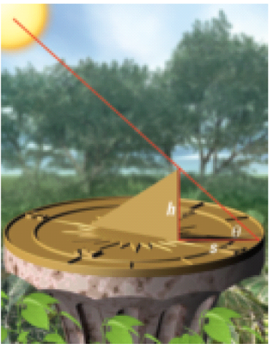
Example 5: Verify a Real-Life (what?!) Trigonometric Identity
A vertical gnomon (the part of a sundial that projects a shadow) has height h. The length s of the shadow cast by the gnomon when the angle of the sun above the horizon is $θ$ can be modeled by the equation below. Show that the equation is equivalent to $s = h cot θ$.
$$s=\frac{hsin(90°-θ)}{sinθ}$$

YOU TRY:
Verify the identity.
6. $cot (– θ ) = – cot θ$ 7. $\csc^{2}{x} \left(1 –\sin^{2}{x}\right)=\cot^{2}{x}$

8. $cos x csc x tan x = 1$ 9. $\left(\tan^{2}{x}+ 1\right)\left(\cos^{2}{x} – 1\right)= –\tan^{2}{x}$

KEEP GOING:
1. Given that $cosθ=\frac{8}{17}$, and $\frac{3π}{2}< θ < 2π$ find the values of $csc θ$ and $cot θ.$

- The population b₁ of bacteria in a culture is dependent on the population b₂ of another bacteria in the culture and can be modeled by the function $b_{1}=\frac{b_{2}tan(\frac{π}{2}-θ)}{cscθ}$. Simplify $\frac{b_{2}tan(\frac{π}{2}-θ)}{cscθ}$ to show that the equation is equivalent to $b_{1}=b_{2}cosθ$.
Hw: Section 10.3 p. 631 #3-13 all

