Name: Date:
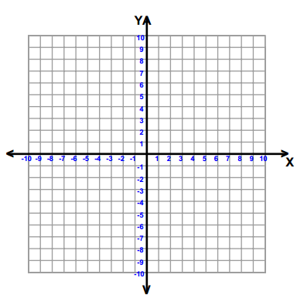
10.5 Notes: Square Root Function
Graph using a table of values.
$$y= \sqrt{x}$$
X | Y
0
1
2
3
4

Recall: Graphing by Translation
A. $y= {(x-6)}^{2}+5$ B. $y= {(x+3)}^{2}+1$ C. $y= {(x-9)}^{2}-10$

Applying to Square Root Functions
A. $y= \sqrt{x}+5$ B. $y= \sqrt{x+4}$ C. $y= \sqrt{x-9}$

D: _____________________ D: _____________________ D: _____________________
R: _____________________ R: _____________________ R: _____________________
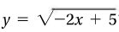
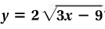
Example 1: Finding Domain without a Graph
A. B.

Why does it work? __________________________________________________________________________________

Graph Using a Table of Values
A. $y= 2\sqrt{x-4}+5$ B. $y= -\sqrt{x+1}$
Hw: Section 10.5 p. 642 # 7-15 odd, 26-29, 31-37 odd, 55-58

