STATION 1: ***Don’t forget to State Restrictions***
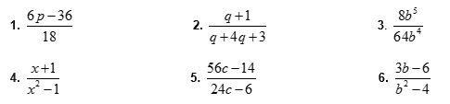

STATION 2: ***Don’t forget to State Restrictions***
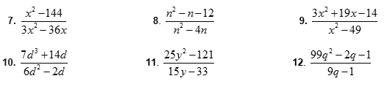

STATION 3: ***Don’t forget to State Restrictions***
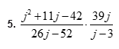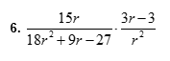

STATION 4: ***Don’t forget to State Restrictions***
Multiply.
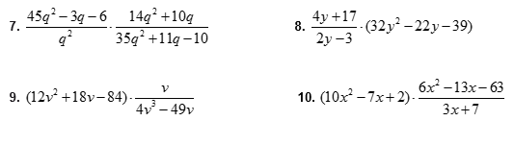
STATION 5: ***Don’t forget to State Restrictions***
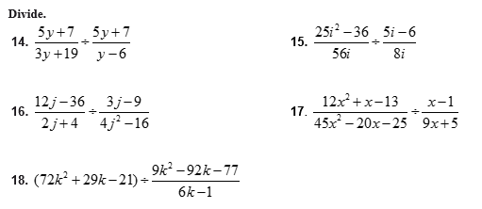

STATION 6: ***Don’t forget to State Restrictions***
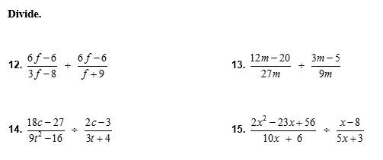

STATION 1: ***Don’t forget to State Restrictions***
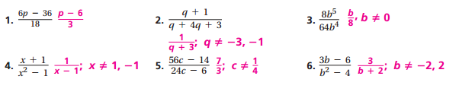
STATION 2: ***Don’t forget to State Restrictions***
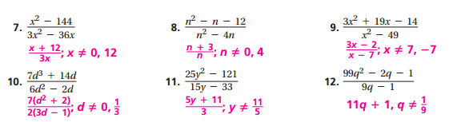
STATION 3: ***Don’t forget to State Restrictions***
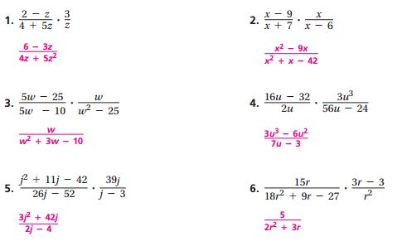
STATION 4: ***Don’t forget to State Restrictions***
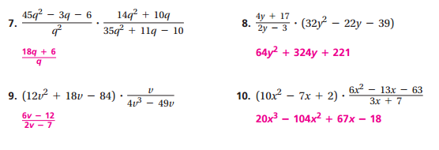

STATION 5: ***Don’t forget to State Restrictions***
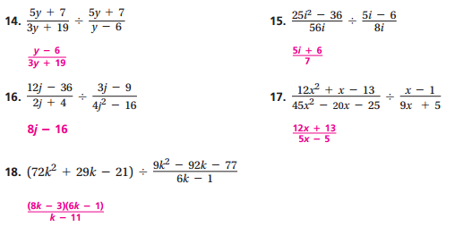
STATION 6: ***Don’t forget to State Restrictions***
