Name: Date:
11.4 Notes
Review: Adding and Subtracting Fractions
1. $\frac{3}{4}+ \frac{1}{8}$ 2. $\frac{2}{7}+ \frac{1}{5}$ 3. $\frac{2}{9}+ \frac{5}{12}$ 4. $\frac{5}{7}+8$ 5. $\frac{1}{3x}+\frac{2}{3}$

LCD: LCD: LCD: LCD: LCD:

Find the sum or difference.
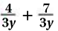
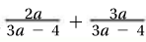
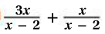
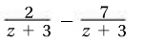
6. 7. 8. 9.

LCD: LCD: LCD: LCD:
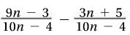
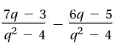
Example 1: 10.

LCD: LCD:
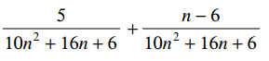
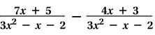
Example 2: 11.

LCD: LCD:

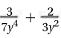
Example 3: Adding with Different Denominators 12.
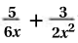

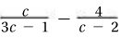
Example 4: Different Denominators 13.
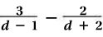

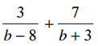
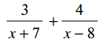
14. 15.

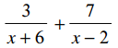
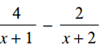
16. 17.
Hw: Section 11.4 p. 687 #8-16 all

