Name: Date:
11.6 Notes
Direct Variation | Inverse Variation

What does every equation need?

Example 1: Writing an Equation

Suppose y varies inversely with x, and y = 8 when x = 3. What is the equation for the inverse variation?

1. Suppose y varies inversely with x, and y = 8 when x = 3. What is the equation for the inverse variation?

Example 2: What is happening graphically?
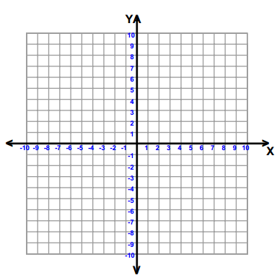
Use the equation to fill out the table: $y= \frac{18}{x}$
x | y

Example 3: Graphing $y= \frac{8}{x}$
x | y
-8
8

3. Graphing $y= \frac{-4}{x}$
x | y
-8
8

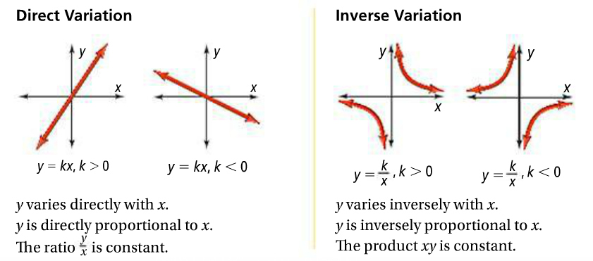

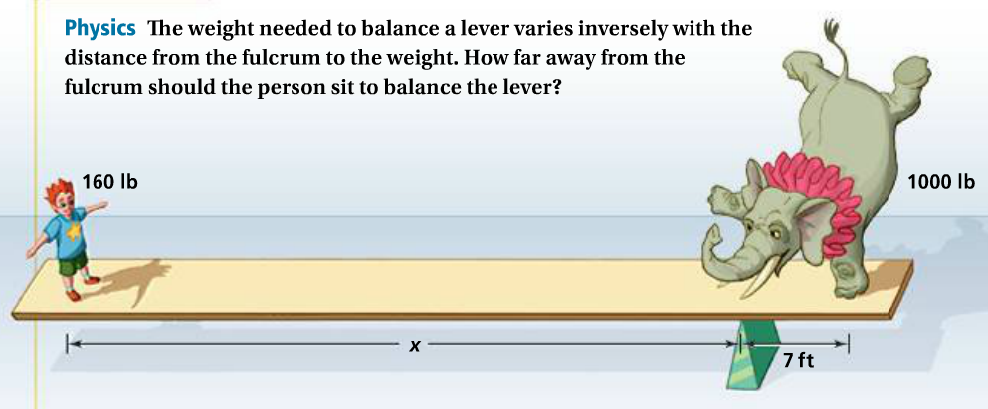
Example 4: Word Problem $w_{1}{∙d}_{1}=w_{2} {∙ d}_{2}$

3. A 1,000lb elephant is 15 feet from a fulcrum and the trainer weighing 175 lbs is balanced across. How far away from the fulcrum should the trainer stand?

Example 5: Writing Equations
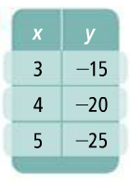
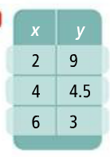

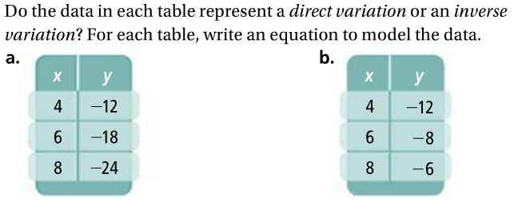
5.

Strategies + Patterns to Look For

Example 6:
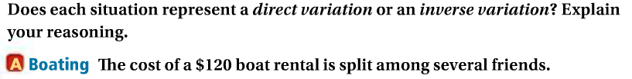

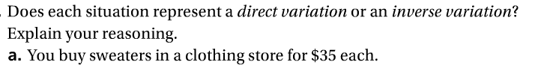
6.

