Name: Date:
11.7 Notes
Rational Function: | Example:

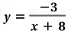
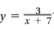
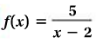
State the excluded value for each function.
Example 1: 2. 3.

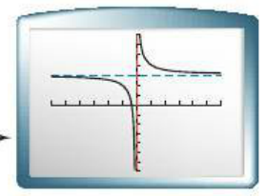
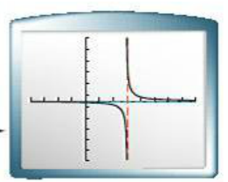
Noticing Patterns in Graphs
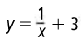
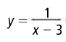
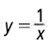
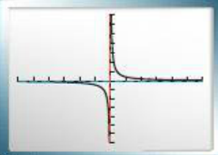

Asymptote: ______________________________________________________________________________________
Identify the asymptote (Box answer). Graph the function.
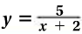
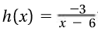
Example 2: 4.
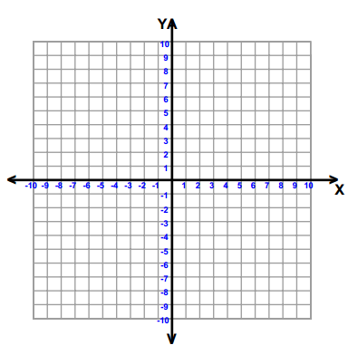

Identifying Asymptotes
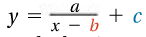 | Example:  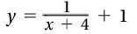
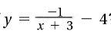
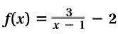
Example 3: 5.

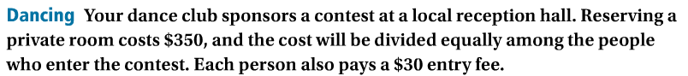
Example 5:

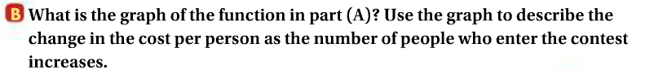
Hw: Section 11.7 p. 710 #9-21 odd

