2.10 Change Expressed as a Percent:
Obj: To find the percent change. To find the relative error in linear and nonlinear measurements.
Starter:
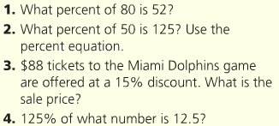

A __________________ expresses an amount of change as a percent of an original amount.
If a new amount is greater than the original amount, the percent change is called a ______________________.
If a new amount is less than the original amount, the percent change is called a ______________________.

KEY CONCEPT:
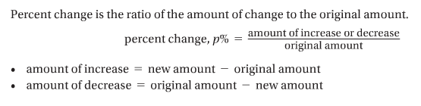
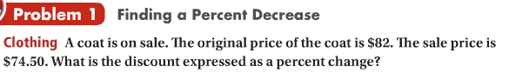

You try:
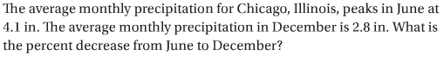

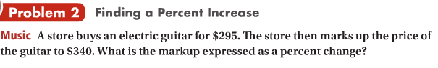

You try:

Key Concept:
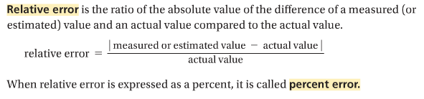
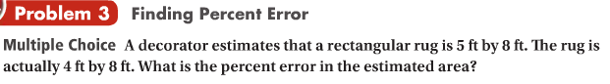

You Try:
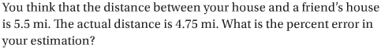

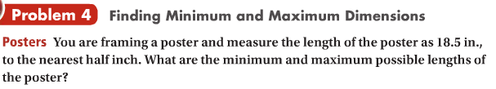

You Try:

