Algebra 2 w/ Trig
2.1 Use Properties of Exponents
Warm- Ups:
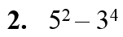
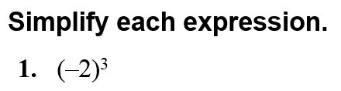

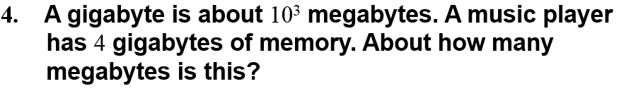

------------------------------------------------------NOTES------------------------------------------------------------------------------------
Example 1: Evaluate Numerical Expressions
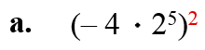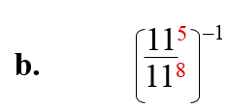

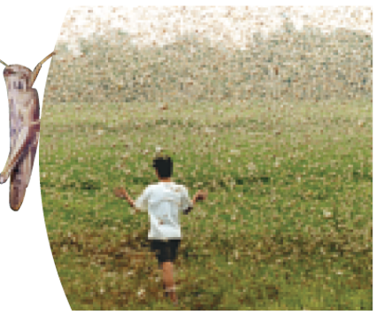
Example 2: Use Scientific Notation in Real Life
A swarm of locusts may contain as many as 85 million locusts per square kilometer and cover an area of 1200 square kilometers. About how many locusts are in such a swarm?

YOU TRY:
Evaluate the expression. Tell which properties of exponents you used.
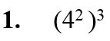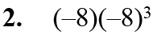

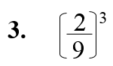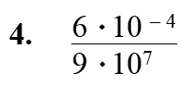

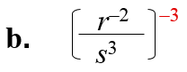
Example 3: Simplify Expressions
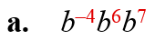
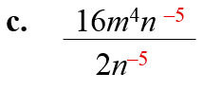

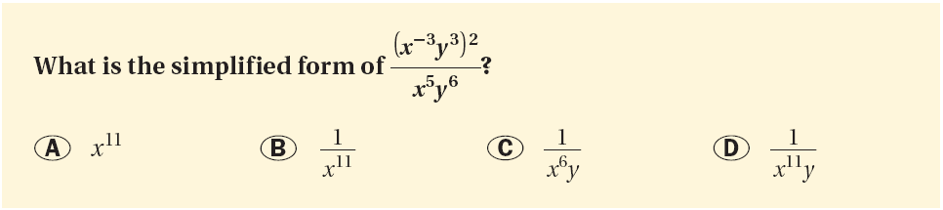
Example 4: Compare Real Life Volumes
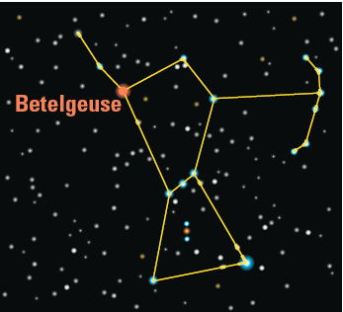
Betelgeuse is one of the stars found in the constellation Orion. Its radius is about 1500 times the radius of the sun. How many times as great as the sun’s volume is Betelgeuse’s volume?

YOU TRY:
Simplify the expression. Tell which properties of exponents you used.
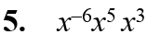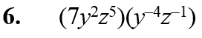

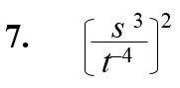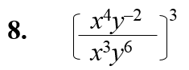

KEEP GOING:
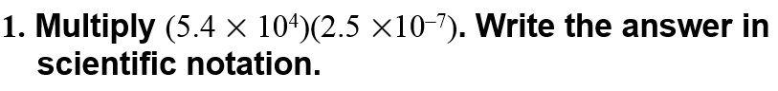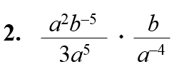

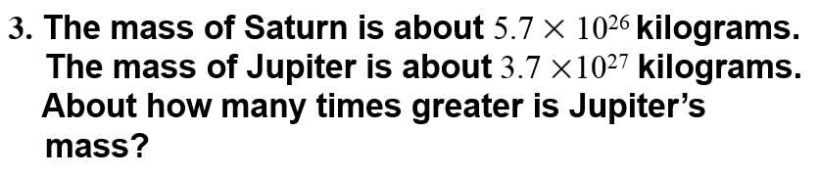
Hw: Section 2.1 p. 91 #3-39 odds

