Algebra w/ Trig
2.2 Evaluate and Graph Polynomial Functions
Warm-Up:
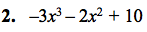

3. The expression x² – 4 represents the of matting in square inches that is need to mat picture. How much matting is needed if x = 6?

--------------------------------------------------------NOTES----------------------------------------------------------------------

Example 1: Identify Polynomial Functions
Decide whether the function is a polynomial function.
If so, write it in standard form and state its degree, type, and leading coefficient.

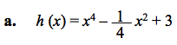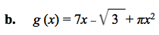

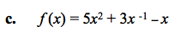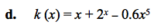

Example 2: Evaluate by Direct Substitution

Use direct substitution to evaluate f (x) = 2x⁴ – 5x³ – 4x + 8 when x = 3.

YOU TRY:
Decide whether the function is a polynomial function. If so, write it in standard form and state its degree, type, and leading coefficient.

1. f (x) = 13 – 2x 2. p (x) = 9x⁴ – 5x ^{– 2} + 4 3. h (x) = 6x² + π – 3x

Use direct substitution to evaluate the polynomial function for the given value of x.
4. f (x) = x⁴ + 2x³ + 3x² – 7; x = –2 5. g (x) = x ³ – 5x² + 6x + 1; x = 4

Example 3: Evaluating by Synthetic Substitution
Use synthetic substitution to evaluate f (x) from Example 2 when x = 3.
f (x) = 2x4 – 5x3 – 4x + 8

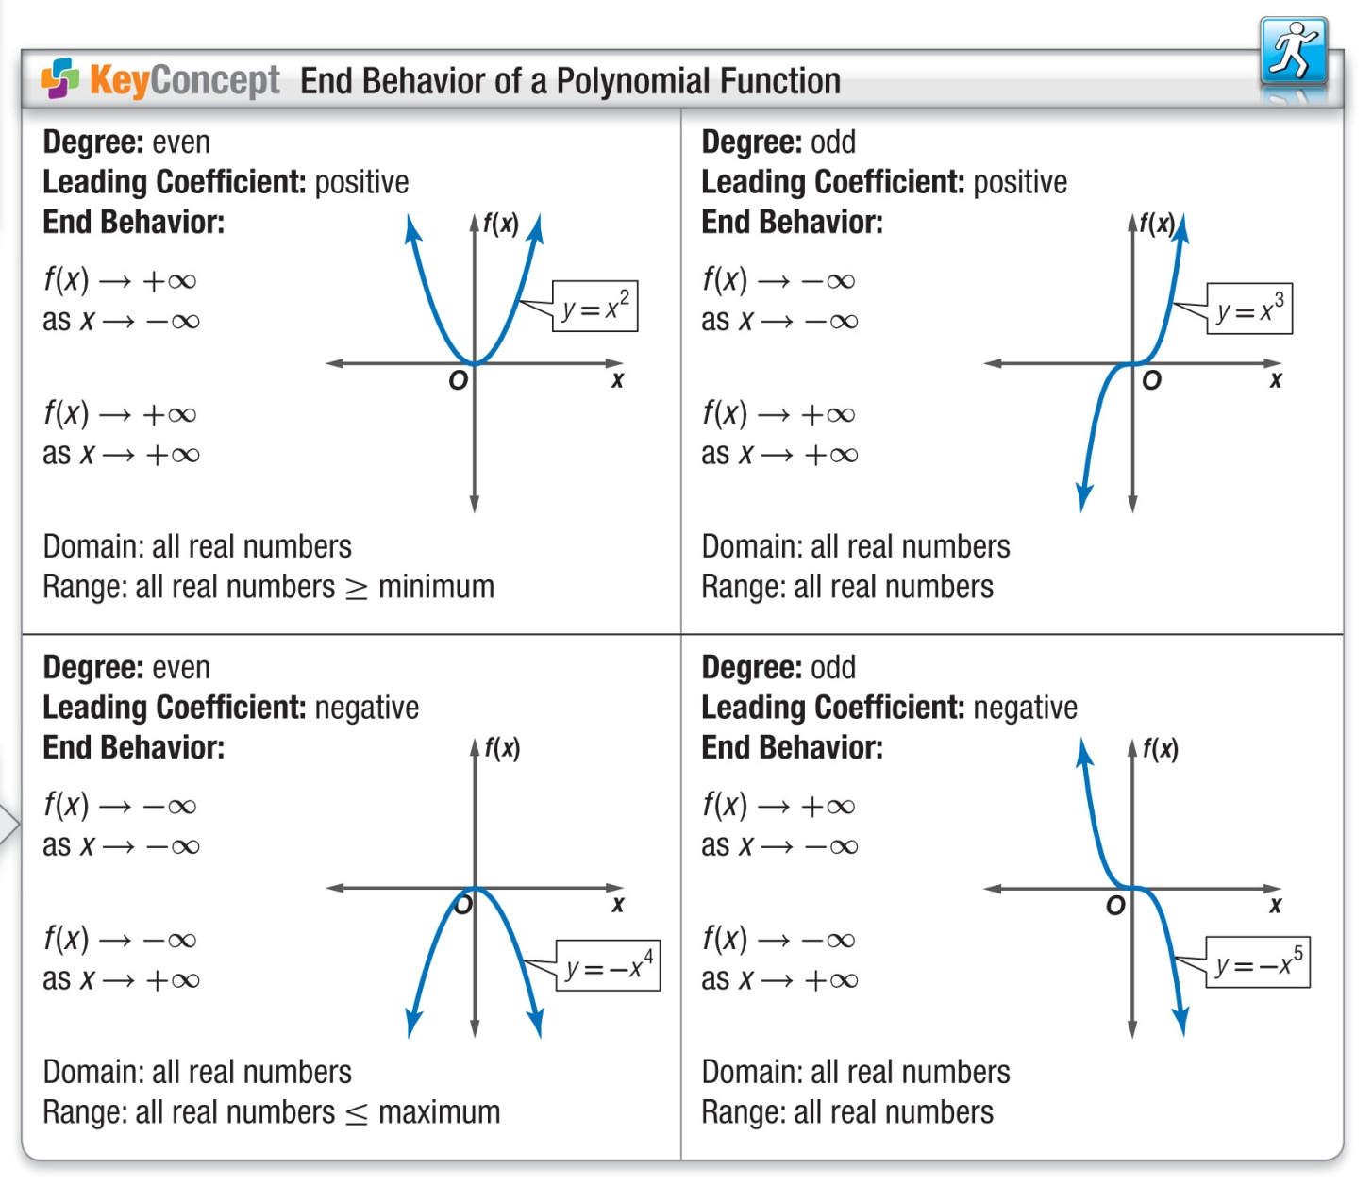

Example 4: Multiple Choice!!
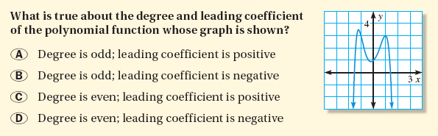

YOU TRY:
Use synthetic substitution to evaluate the polynomial function for the given value of x.
6. f (x) = 5x³ + 3x² – x + 7; x = 2 7. g (x) = – 2x⁴ – x³ + 4x – 5; x = – 1

8. Describe the degree and leading coefficient of the
polynomial function whose graph is shown.
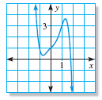

Example 5: Graph Polynomial Functions
Graph (a) f (x) = – x³ + x² + 3x – 3 and (b) f (x) = 5 x⁴ – x³ – 4x² + 4.
x
y
x
y

Example 6: Solve a Multi-Step Problem
The energy E (in foot-pounds) in each square foot of a wave is given by the model E = 0.0029s⁴ where s is the wind speed (in knots). Estimate the wind speed needed to generate a wave with 1000 foot-pounds of energy per square foot.

YOU TRY:
Hw: Section 2.2 p. 99 #3-45 odd

Graph the polynomial function.
9. f (x) = x⁴ + 6x² – 3 10. f (x) = 2x³ + x² + x – 1
x
y
x
y

11. f (x) = 4 – 2x³
12. WHAT IF? If wind speed is measured in miles per hour, the model in Example 6 becomes
E = 0.0051s⁴. What wind speed is needed to generate a wave with 2000 foot-pounds of energy per square foot?

x
y

KEEP GOING:
3. The estimated number of electric vehicles V in the United States from 1995 to 2004 is given by the equation V = 10x⁴ + 200x + 3000, where x is the number of years since 1995. Estimate the number of electric Vehicles in 2003.

1. Tell whether the function f(x) = – 3x³ – 5x ^{–1} + 8 is
a polynomial function. If so, write it in standard
form and state its degree, type, and leading
coefficient.

2. Use synthetic substitution to evaluate
f(x) = 4x⁴ – x³ + 3x² + 5x – 3 when x = – 2

