Algebra 2 w/ Trig
2.3 Add, Subtract and Multiply Polynomials

Warm- Up:
Simplify the expression.

1. (–3x³)(5x) 2. 9x – 18x 3. 10y² + 7y – 8y² – 1 4. 4(– 5a + 6) –2(a – 8)

5. Each side of a square is (2x + 5) inches long. Write an expression for the perimeter of the square.

------------------------------------------------------NOTES------------------------------------------------------------------------
Example 1: Add Polynomials Vertically and Horizontally
a. Add 2x³ – 5x² + 3x – 9 and x³ + 6x² + 11
b. Add 3y³ – 2y² – 7y and
– 4y² + 2y – 5 in a horizontal format.

in a vertical format.

Example 2: Subtract Polynomials Vertically and Horizontally
a. Subtract 3x³ + 2x² – x + 7 from
b. Subtract 5z² – z + 3 from
4z² + 9z – 12 in a horizontal format.

8x³ – x² – 5x + 1 in a vertical format.

YOU TRY:
Find the sum or difference.
1. (t² – 6t + 2) + (5t² – t – 8) 2. (8d – 3 + 9d³) – (d³ – 13d² – 4)

Example 3: Multiply Polynomials Vertically and Horizontally
b. Multiply x + 3 and 3x² – 2x + 4 in a horizontal format.

a. Multiply – 2y² + 3y – 6 and y – 2 in a
vertical format.

Example 4: Multiply Three Binomials
Multiply x – 5, x + 1, and x + 3 in a horizontal format.

Example 5: Use Special Product Patterns
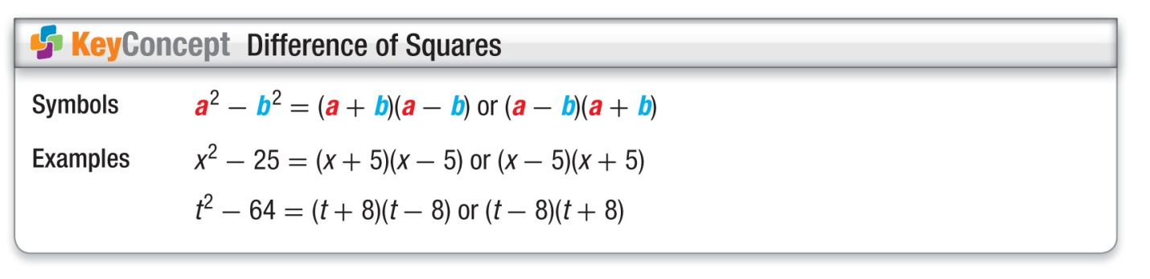
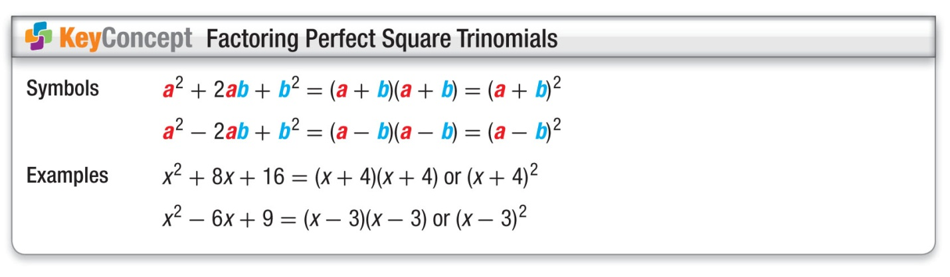
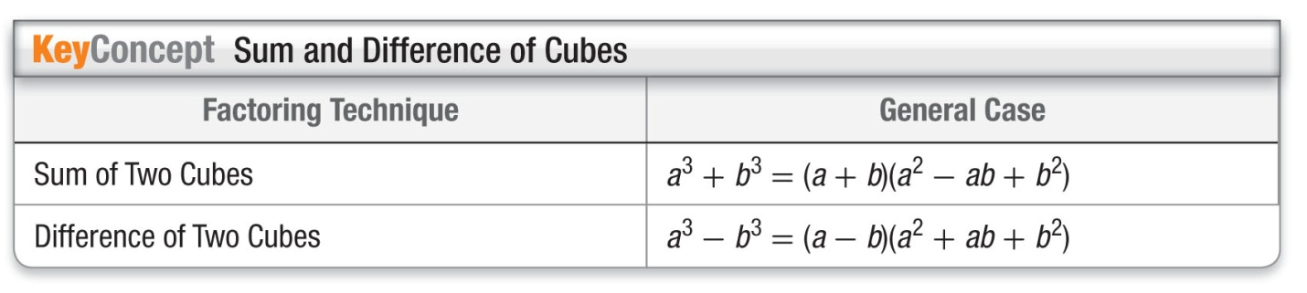

a. (3t + 4)(3t – 4) b. (8x – 3)² c. (pq + 5)³

YOU TRY:
Find the product.
3. (x + 2)(3x² – x – 5) 4. (a – 5)(a + 2)(a + 6) 5. (xy – 4)³

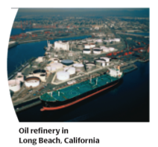
Example 6: Using Polynomial Models
Since 1980, the number W (in thousands) of United States wells producing crude oil and the average daily oil output per well O (in barrels) can be modeled by

W = – 0.575t² + 10.9t + 548 and O = – 0.249t + 15.4

where t is the number of years since 1980. Write a model for the average total amount T of crude oil produced per day. What was the average total amount of crude oil produced per day in 2000?

YOU TRY:
The models below give the average depth D (in feet) of new wells drilled and the average cost per foot C (in dollars) of drilling a new well. In both models, t represents the number of years since 1980. Write a model for the average total cost T of drilling a new well.
D = 109t + 4010 C = 0.542t² – 7.16t + 79.4

KEEP GOING:
Hw: Section 2.3 p. 107 #3-47 odd

Find the sum, difference, or product.

1. (3x² + 5x + 2) + (x² – 3x + 6) 2. (5p³ + 2p² – 3p – 7) - (2p³ – 4p² – 5p + 6)

3. (5a² + 6a + 9)(2a – 3) 4. 6(x – 1)(x + 1)

