2-3 Solving Multi- Step Equations
Objective: To solve multi-step equations.
Starter:
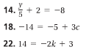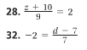

ESSENTIAL UNDERSTANDING:
To solve multi – step equations, you form a series of simpler equivalent equations. To do this, use the __________________________, _________________________, and ______________________.
Keep using the properties until you _____________________ the variable.

Combining Like terms:
What is the solution of _____________________________?

What is the solution of each equation? Check each answer:
- b.

Solving a Multi-step word problem.
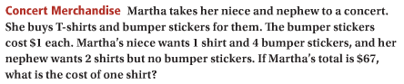

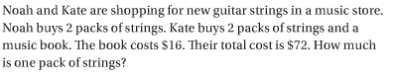

Solving an Equation using the Distributive Property:
What is the solution of _________________________?

You try: solve: _____________________________

Solving an equation that contains fractions:
Solve:___________________________________

Method 1:

Method 2:

HW: Pg 98 # 22-38 even

