2-4 Solving Equations with Variables of both sides:
Objectives: To solve equations with variables on both sides. To identify equations that are identities or have no solution.
Starter(s):
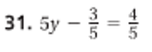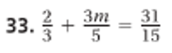

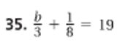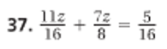

Solving an Equation with variables on both sides:
Solve: __________________________________

You try:
- ____________________________ b. ______________________________

Solving Equations with Grouping Symbols:
Solve: ___________________________________

You try:
- _______________________________ b. ______________________________

Identities and Equations with No Solution:
What is the solution of each equation:

- ______________________________ b. ______________________________

You try:
- ________________________________ b. ________________________________

HW: Pg 106 #19, 20, 21-39odd, 44

