Algebra 2 w/ Trig
2.4 Factor and Solve Polynomial Equations
Warm – Up:
Multiply the polynomial.
1. (x + 2)(x + 3) 2. (2x – 1)(2x + 1) 3. (x – 7)² 4. 3x²(x + 5)

5. The dimension of a box are modeled by (x + 4), (x + 2) and (x + 6). Write a polynomial that models the volume of the box.

-------------------------------------------------------------------------NOTES------------------------------------------------------------------------------
Example 1: Find a Common Monomial Factor
Factor the polynomial completely.
a. x³ + 2x² – 15x b. 2y⁵ – 18y³ c. 4z⁴ – 16z³ + 16z²

Example 2: Factor the Sum or Difference of Two Cubes
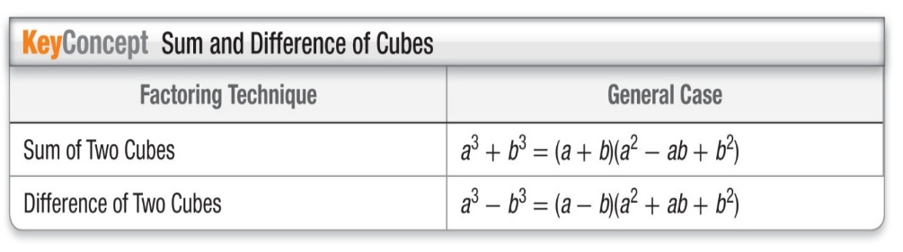
a. x³ + 64 b. 16z⁵ – 250z²

Factor the polynomial completely.
1. x³ – 7x² + 10x 2. 3y⁵ – 75y³ 3. 16b⁵ + 686b² 4. w³ – 27

Example 3: Factor by Grouping
x³ – 3x² – 16x + 48

Example 4: Factor Polynomials in Quadratic Form
Factor completely: (a) 16x⁴ – 81 (b) 2p⁸ + 10p⁵ + 12p².

YOU TRY:
Factor the polynomial completely.
5. x³ + 7x² – 9x – 63 6. 16g⁴ – 625 7. 4t⁶ – 20t⁴ + 24t²

Example 5: Find the real-number solutions of the equation.
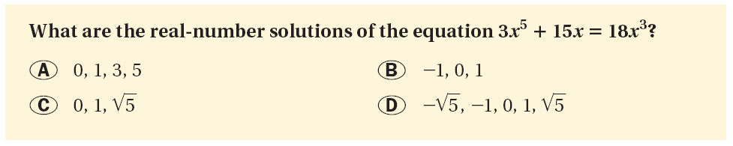

Find the real-number solutions of the equation.
8. 4x⁵ – 40x³ + 36x = 0 9. 2x⁵ + 24x = 14x³ 10. – 27x³ + 15x² = – 6x⁴

Example 6: Solve a Polynomial Equation
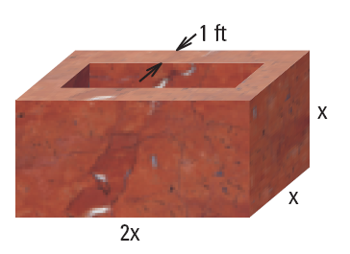
You are designing a marble basin that will hold a fountain for a city park. The basin’s sides and bottom should be 1 foot thick. Its outer length should be twice its outer width and outer height.
What should the outer dimensions of the basin be if it is to hold 36 cubic feet of water?

YOU TRY:
What if ? In Example 6, what should the basin’s dimensions be if it is to hold 128 cubic feet of water and have outer length 6x, width 3x, and height x ?

Hw: Section 2.4 p. 115 #24-29 all

KEEP GOING:
Factor the polynomial completely.
1. 27 – y³ 2. 28x³ – 7x² + 36x – 9

3. What are the real number solutions of the equation 2x = x² + x³?
4. The width of a rug is 3 feet shorter than its length. If the area of the rug is 108 square feet, what are the dimensions of the rug?

