2.5 Literal Equations and Formulas
Objective: To rewrite and use literal equations and formulas.
To isolate variables within equations and formulas.
Starter:
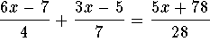
2(3x - 7) + 4 (3 x + 2) = 6 (5 x + 9 ) + 3

A _________________ is an equation that involves two or more variables.

Rewriting a literal equation:
The equation _______________, where x is the number of pizzas and y is the number of sandwiches purchased. How many sandwiches can you buy if you buy 3 pizzas? 6 pizzas?

Solve the equation for y.

Use the rewritten equation to find y when x=3 and when x=6

On your own:
- Solve the equation ___________________ for m. Solve the equation when n = -2, 0, and 2.

Rewriting an equation with only variables:
What equation do you get when you solve _______________ for x?

- Solve the same equation for b. b. Solve ______________________ for x.

Rewriting a Geometric Formula:
What is the radius of a circle with circumference 64 ft? Round to the nearest tenth. Use 3.14 for π.

What is the height of a triangle that has an area of 24 square inches and a base with a length of 8 inches.

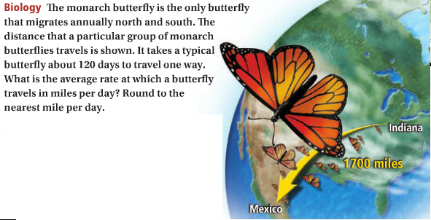

On Your Own:
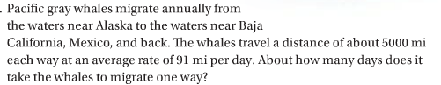

HW: Pg. 112 # 1-43odd may need chart on 110.

PRACTICE:
