Notes – College Algebra
Section 2.6 – Ratios, Rates and Conversions

Name: _____________________________ Date: _________

Starter: Solve these equations

- $Solve the equation for y. Then find the value of y for each value of x.$

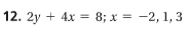

- $Solve each equation for x.$

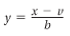

Notes:

Ratio:

Rate:

Problem 1: Comparing Unit Rates
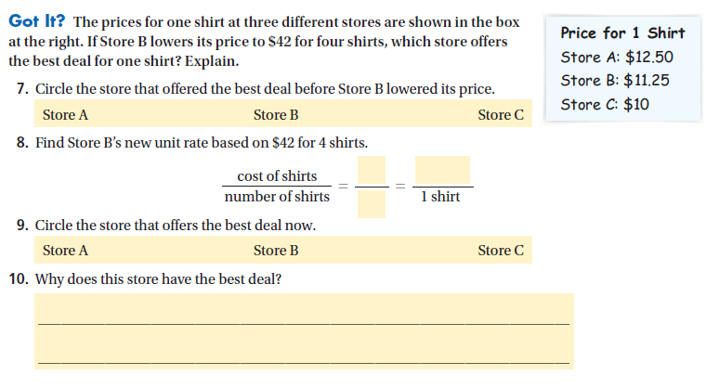
Conversion Factor:

Problem 2: Converting Units
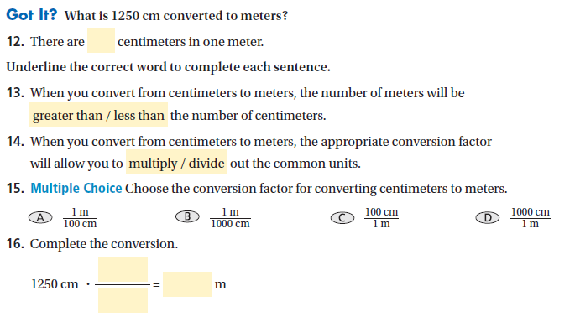

Problem 3: Converting Units Between Systems
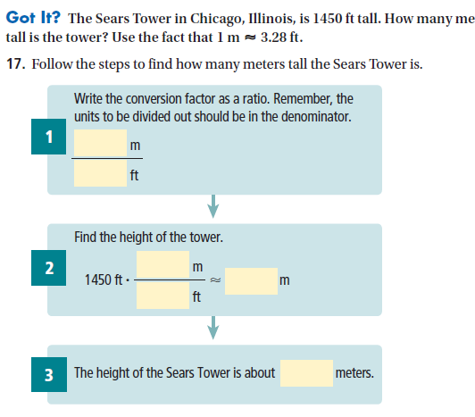

Problem 4: Converting Rates
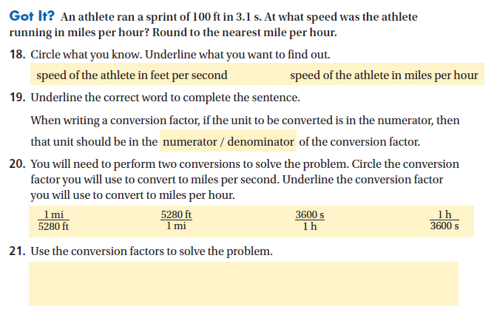

Let’s try this on our own…
Problem 1: You are shopping for t-shirts. Which store offers the best deal?
Store A: $25 for 2 shirts Store B: $45 for 4 shirts Store C: $30 for 3 shirts

Write each price as a ration. Then write the ratio as a unit to compare.

Problem 2: What is the given amount converted to the given units?
- 330 min to hours

- 15 kg to grams

- 5 feet 3 inches to inches

Problem 3: The CN tower in Toronto, Canada, is about 1815 ft tall. About how many meters tall is the tower? Use the fact that 1 meter = 3.28 feet.

Problem 4: A student ran the 50-yard dash in 5.8s. At what speed did the student run in miles per hour?

