Algebra 2 w/ Trig
2.6 Finding Rational Zeros
Warm-Up:
Factor completely.
1. x² – x – 12 2. 2x² – 5x – 3 3. Use synthetic division to divide
2x³ – 3x² – 18x – 8 by x – 4.

4. The volume of a box is modeled by f (x) = x (x – 1)(x – 2), where x is the length in meters. What is the volume when the length is 3 meters.

-------------------------------------------------------------NOTES-----------------------------------------------------------------------------Example 1: List Possible Rational Zeros
List the possible rational zeros of f using the rational zero theorem.
EXAMPLE: | a. f (x) = x³ + 2x² – 11x + 12 | b. f (x) = 4x⁴ – x³ – 3x² + 9x – 10
Factors of the constant term:
Factors of the leading coefficient:
Possible rational zeros:
Simplified list of possible zeros:
YOU TRY:
EXAMPLE: | 1. f (x) = x³ + 9x² + 23x + 15 | 2. f (x) =2x³ + 3x² – 11x – 6
Factors of the constant term:
Factors of the leading coefficient:
Possible rational zeros:
Simplified list of possible zeros:
Example 2: Find Zeros when the Leading Coefficient is 1.
Find all real zeros of f (x) = x³ – 8x² +11x + 20.

YOU TRY:
Find all real zeros of the function.
3. f (x) = x³ – 4x² – 15x + 18 4. f (x) + x³ – 8x² + 5x+ 14

Example 3: Find Zeros when the Leading Coefficient is not 1.
Find all real zeros of f (x) =10x⁴ – 11x³ – 42x² + 7x + 12.

YOU TRY:
Find all real zeros of the function.
5. f (x) = 48x³+ 4x² – 20x + 3 6. f (x) = 2x⁴ + 5x3 – 18x² – 19x + 42

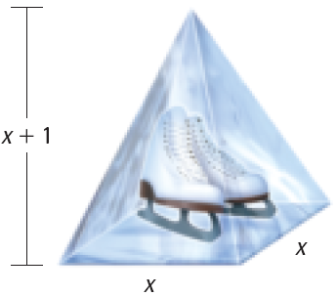
Example 4: Solve a Multi-Step Problem
Some ice sculptures are made by filling a mold with water and then freezing it. You are making such an ice sculpture for a school dance. It is to be shaped like a pyramid with a height that is 1 foot greater than the length of each side of its square base. The volume of the ice sculpture is 4 cubic feet. What are the dimensions of the mold?

Hw: Section 2.6 p. 132 #11-18, 24-35, 41-43
YOU TRY:
7. WHAT IF? In Example 4, suppose the base of the ice sculpture has sides that are 1 foot longer than the height. The volume of the ice sculpture is 6 cubic feet. What are the dimensions of the mold?

KEEP GOING:
1. List the possible rational zeros of
4. The volume V of a storage shed with a triangular
roof can be modeled by V = x³ + x²(6 – x). If
the volume of the shed is 80 cubic feet, find x.

f(x) = x³ + 8x² – x + 4.

For 2 and 3, find all real zeros of the functions
2. f(x) = x³ – 3x² – 6x + 8.

3. f(x) = 2x³ – 3x² – 17x + 30.

