Algebra 2 w/ Trig
2.7 Apply the Fundamental Theorem of Algebra
Warm-Up:
1. What is the degree of f (x) = 8x⁶ – 4x⁵ + 3x² + 2? 2. Solve x² – 2x + 3 = 0

3. The function P given by x⁴ + 3x³ – 30x² – 6x = 56 model the profit of a company. What are the real solution of the function?

--------------------------------------------------------------NOTES-----------------------------------------------------------------------------------------
Example 1: Find the number of solutions of zeros
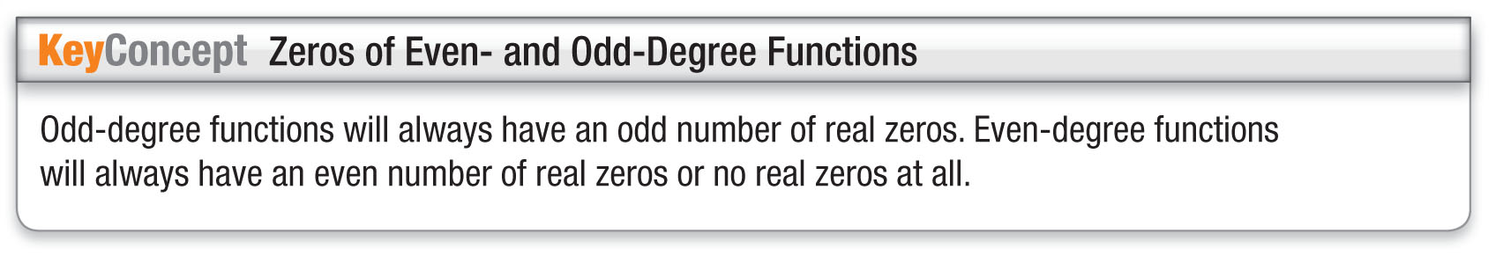
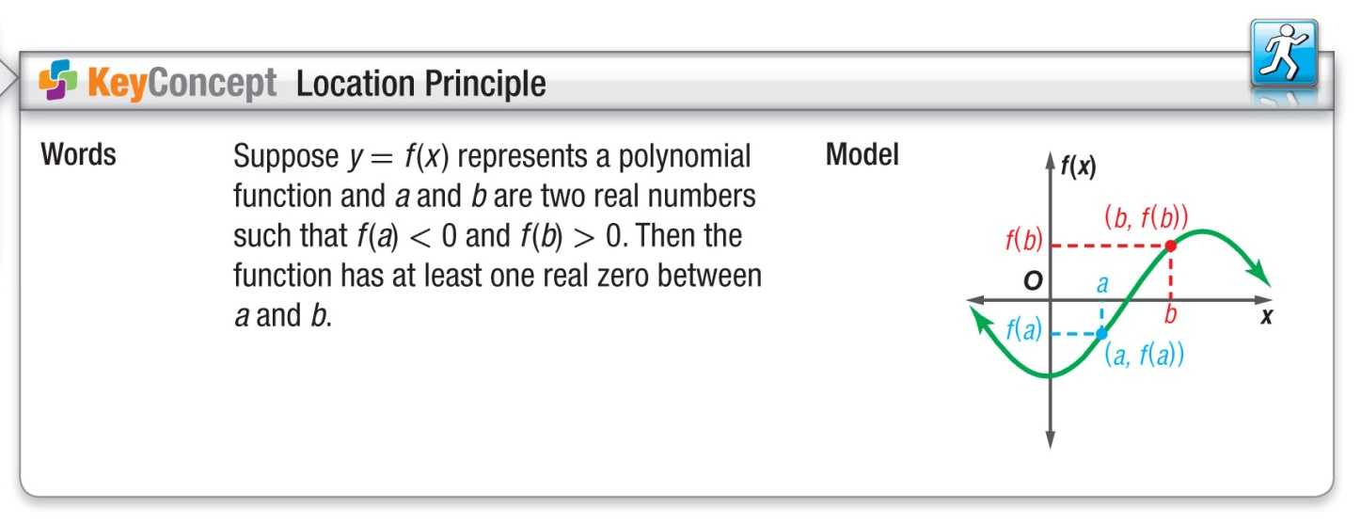

Example 1: Find the Number of Solutions or Zeros
a. How many solutions does the equation
x³ + 5x² + 4x + 20 = 0 have?

YOU TRY:
1. How many solutions does the equation
x⁴ + 5x² – 36 = 0 have?

b. How many zeros does the function
f (x) = x⁴ – 8x³ + 18x² – 27 have?

2. How many zeros does the function
f (x) = x³ + 7x² + 8x – 16 have?

Example 2: Find the zeros of the Polynomial Function YOU TRY:
Find all zeros of f (x) = x⁵ – 4x⁴ + 4x³ + 10x² – 13x – 14. | 3. Find all the zeros of f (x) = x³ + 7x² + 15x + 9

Example 3: Use Zeros to Write a Polynomial Function
Write a polynomial function f of least degree that has rational coefficients, a leading coefficient of 1, and 3 and
$2±\sqrt{5}$as zeros.

4. $4, 1±\sqrt{5}$ | 5. $2,± 2i, 4±\sqrt{6}$
YOU TRY: Write a polynomial function f of least degree that has rational coefficients, a leading coefficient of 1, and the given zeros.

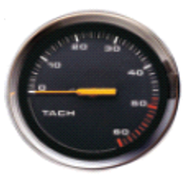
Example 4: Approximate Real Zeros of a Polynomial Model
A tachometer measures the speed (in revolutions per minute, or RPMs) at which an engine shaft rotates. For a certain boat, the speed x of the engine shaft (in 100s of RPMs) and the speed s of the boat (in miles per hour) are modeled by
s (x) = 0.00547x³ – 0.225x² + 3.62x – 11.0
What is the tachometer reading when the boat travels 15 miles per hour?

YOU TRY:
6. Approximate the real zeros of  f (x) = 3x⁵ + 2x⁴ – 8x³ + 4x² – x – 1. | 7. The profit P for printing envelopes is modeled  by P = x – 0.001x³ – 0.06x² + 30.5x, where x is  the number of envelopes printed in thousands.  What is the least number of envelopes that  can be printed for a profit of $1500?
Hw: Section 2.7 p. 141 #3-9, 10-13, 20-25, 42-49
KEEP GOING:
- Find all the zeros of f(x) = x⁴ – x² – 20. | 2. Write a polynomial function of least degree  that has rational coefficients, a leading  coefficient of 1, and – 3 and 1 – 7i

