College Algebra 2.9 Percents
Objective: To solve percent problems using proportions
To solve percent problems using the percent equation.
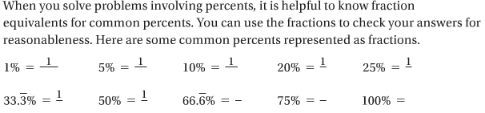
Starter: Fill in the fractions that represent the percents.

The Percent Proportion: You can represent “a is p percent of b” using the percent proportion shown below. In the proportion b is the base and a is a part of base b.
Algebra: __a__=_____ where b≠0
b
- Find a percent using the percent proportion. What percent of 56 is 42?
_____=______

Try it!!
- What percent of 90 is 54?

The Percent Equation. You can represent “a is p percent of b” using the percent equation shown below. In the equation, a is a part of the base b.
Algebra: ____=_____ * _____, where b≠0
2. Find a percent using the percent equation. What percent of 40 is 2.5?

____=_____ * ____

Try it!!
- What percent of 84 is 63? Use the percent equation to solve. Then use the percent proportion. Compare your answers.

Finding a part. 3. A dress shirt that normally costs $38.50 is on sale for 30% off. What is the sale price of the shirt?
Step1. Use the percent equation to find the amount of the discount. a=p% * b

Step 2. Find the sale price.

Try it!!
- A family sells a car to a dealership for 60% less than they paid for it. They paid $9000 for the car. For what price did they sell the car?

Finding a Base. 4. 125% of what number is 17.5? Use the percent equation.

- 30% of what number is 12.5? Solve the problem using the percent equation. Then solve the problem using the percent proportion.

Think about it. If you put $1000 into a savings account giving 3% interest each year, how much interest will you have earned at the end of one year?

The Simple Interest Formula
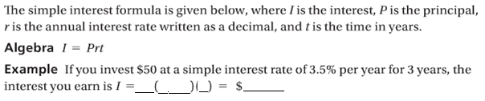

5. Finances. You deposited $840 into a savings account that earns a simple interest rate of 4.5% per year. You want to keep the money in the account for 4 years. How much interest will you earn? Check your answers for reasonableness.

Try it!!
- You deposited $125 in a savings account that earns a simple interest rate of 1.75% per year. You earned a total of $8.75 in interest. For how long was your money in the account?

