Algebra 2 w/ Trig
3.1 nth Roots
Warm-Up:
Evaluate without using a calculator.
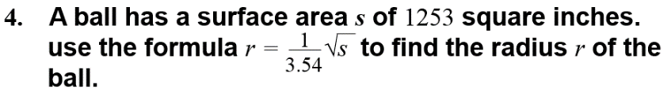
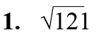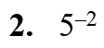

----------------------------------------------------------------NOTES--------------------------------------------------------------------------

Example 1: Find nth roots
Find the indicated real nth root(s) of a.
a. n = 3, a = –216 b. n = 4, a = 81
Example 2: Evaluate Expressions with Rational Exponents
Evaluate (a) 16^{3/2} (b) 32^{–3/5}.

Example 3: Approximate Roots with a Calculator
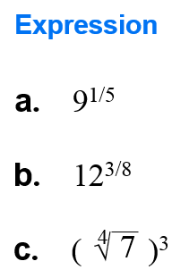

Evaluate expressions without using a calculator.
5. 4^{5/2} 6. 9^{–1/2}

7. 81^{3/4} 8. 1^{7/8}

YOU TRY
Find the indicated real nth root(s) of a.
1. n = 4, a = 625 2. n = 6, a = 64

3. n = 3, a = –64. 4. n = 5, a = 243

Evaluate the expression using a calculator. Round the result to two decimal places when appropriate.
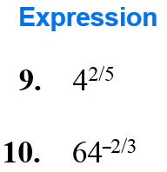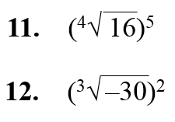
Example 4: Solve Equations Using nth roots
Solve the equation.
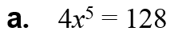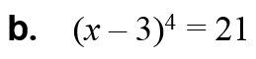

Example 5: Use nth roots in problem solving
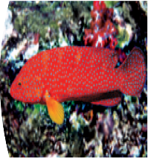
A study determined that the weight w (in grams) of coral cod near Palawan Island, Philippines, can be approximated using the model
w = 0.0167ℓ ³
where l is the coral cod’s length (in centimeters). Estimate the length of a coral cod that weighs 200 grams.

KEEP GOING:
1. Find the nth roots of a if n = 4 and a = 10,000. Solve the equation. Round to two decimal places:
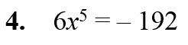

Evaluate the expression without using a calculator 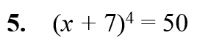
2. 49 ^{–3/2}

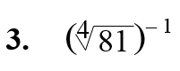

YOU TRY:
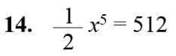
Solve the equation. Round the result to two decimal places when appropriate.
13. x³ = 64

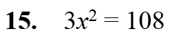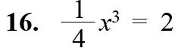

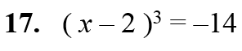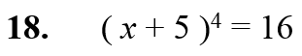

19. WHAT IF? Use the information from Example 5 to estimate the length of a coral cod that has the given weight.
a. 275 grams b. 340 grams

Hw: Section 3.1 p. 169 #1-57 odd

