Algebra 2 w/ Trig
3.2 Apply Properties of Rational Exponents
Warm-Up:
Simplify the expression.
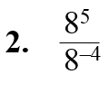
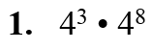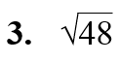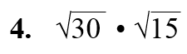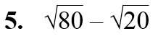

----------------------------------------------------------------NOTES--------------------------------------------------------------------------
Example 1: Use Properties of Exponents
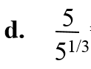
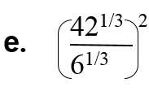
Use the properties of rational exponents to simplify the expression.
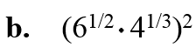
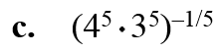
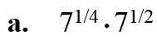

Example 2: Apply Properties of Exponents
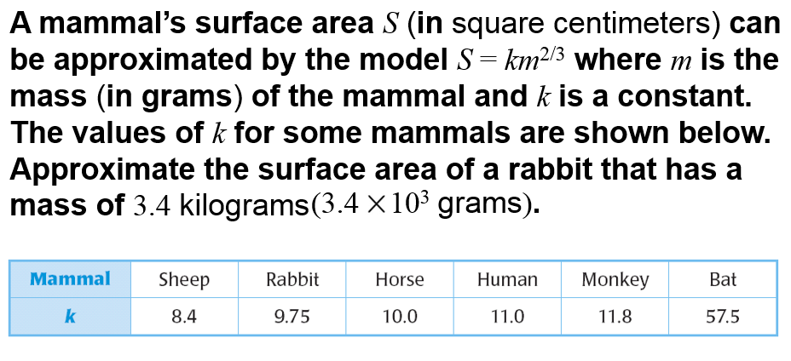
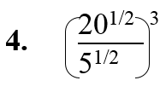
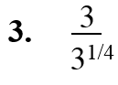
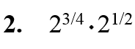
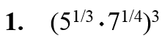
YOU TRY:

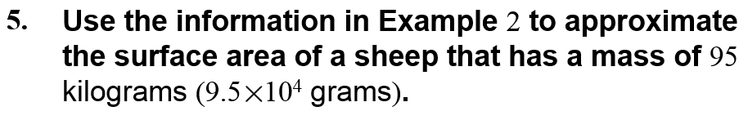

Example 3: Use Properties of Radicals Example 4: Write Radicals in Simplest Form
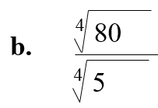
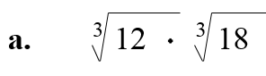
Use the properties of radicals to simplify the expression. Write the expression in simplest form.
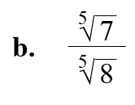
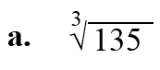

Example 5: Add and Subtract Like Radicals and Roots
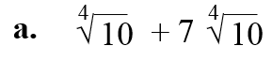
Simplify the expression.
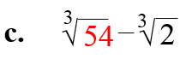
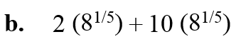

YOU TRY:
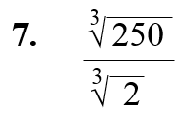
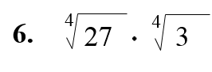
Simplify the expression.

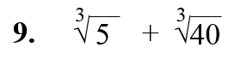
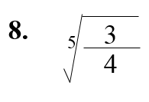

Hw: Section 3.2 p. 176 #15-19, 24-26, 32-36
Algebra 2 w/ Trig
3.2 Day 2!
Warm Up:
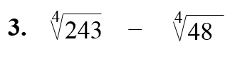
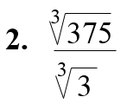
Simplify the expression. Assume all variables are positive.
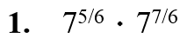

--------------------------------------------------------------NOTES----------------------------------------------------------------------------
Example 6: Simplify Expressions with Variables
Simplify the expression. Assume all variables are positive.
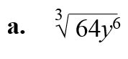
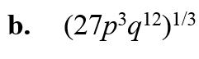

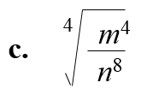
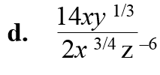

Example 7: Write Variable Expressions in Simplest Form
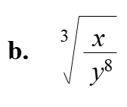
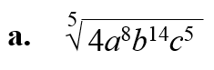
Write the expression in simplest form. Assume all variables are positive.

Example 8: Add and Subtract Expressions with Variables
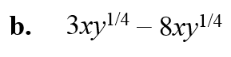
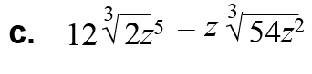
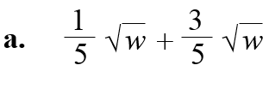
Perform the indicated operation. Assume all variables are positive.

YOU TRY:
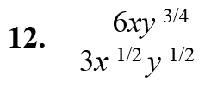
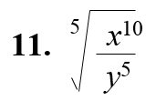
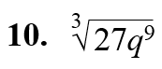
Simplify the expression. Assume all variables are positive.
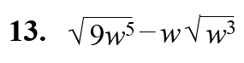

KEEP GOING
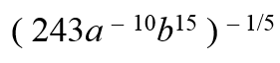
Simplify the expression. Assume all variables are positive.
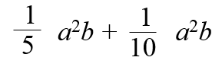
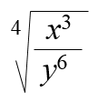
1. 2. 3.

4. What is the length of the hypotenuse of a right triangle if the legs have lengths x and 2x?

Hw: Section 3.2 p. 176 #43-48, 52-54, 60-62

