Algebra 2 w/ Trig
3.3 Perform Operations and Compositions of Functions
Warm-Up:
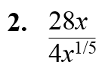
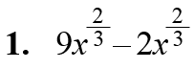
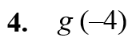
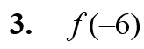
Perform the indicated operation. Assume all variables are positive. Let f (x) = 3x + 5 and g (x) = 2x² – 7. Find the following.

----------------------------------------------------------------------NOTES---------------------------------------------------------------------------------
Example 1: Add and Subtract Functions
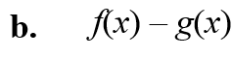
Let f (x) = 4x^{1/2} and g(x) = –9x^{1/2}. Find the following.
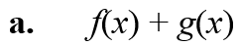

Example 2: Multiply and Divide Functions
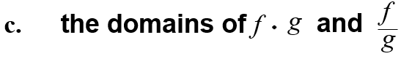
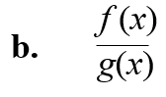
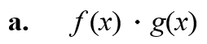
Let f (x) = 6x and g(x) = x^{3/4}. Find the following.

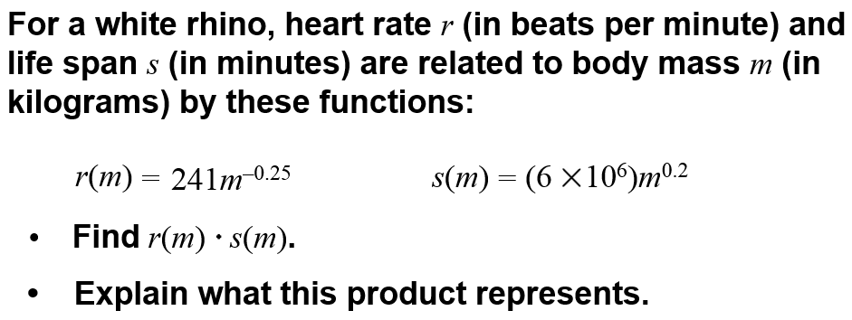
Example 3: Solving a Multistep Problem

YOU TRY:
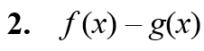
Let f (x) = –2x^{2/3} and g(x) = 7x^{2/3}. Find the following.
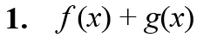

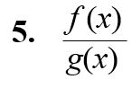
Let f (x) = 3x and g(x) = x^{1/5}. Find the following.
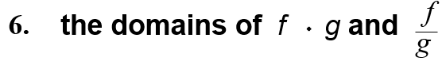
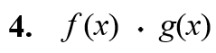

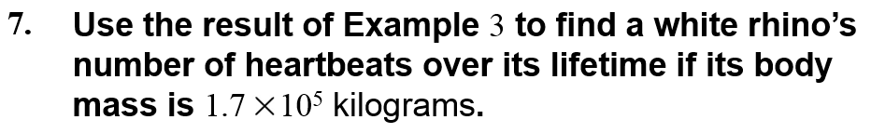

Example 4: Multiple Choice!!!
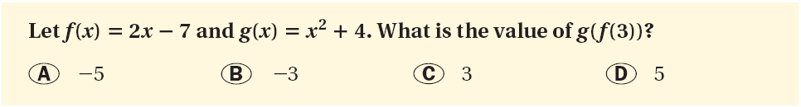

Example 5: Find Compositions of Functions
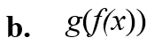
Let f(x) = 4x^{–1} and g(x) = 5x – 2. Find the following.
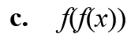
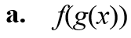

d. What is the domain of f(g(x)) and g(f(x))?
Example 6: Solve a Multi-Step Problem
You have a $10 gift certificate to a paint store. The store is offering 15% off your entire purchase of any paints and painting supplies. You decide to purchase a $30 can of paint and $25 worth of painting supplies.
Use composition of functions to do the following:
- Find the sale price of your purchase when the $10 gift certificate is applied before the 15% discount.

- Find the sale price of your purchase when the 15% discount is applied before the $10 gift certificate.

YOU TRY:
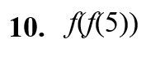
Let f(x) = 3x – 8 and g(x) = 2x². Find the following.
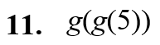
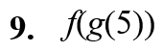
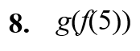

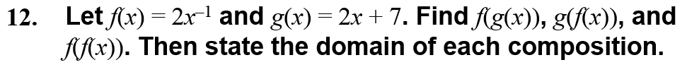

13. What If? In Example 6, how do your answers change if the gift certificate to the paint store is $15 and the store discount is 20%?

Hw: Section 3.3 p. 184 #3-35 odds
KEEP GOING:
Let f(x) = – 2x^{1/4} and g(x) = 6x^{1/4}. Find the following.
1. f(x) + g(x) 2. g(x) – f(x) 3. g(x) $∙$ g(x) 4. the domain of f $∙$ g

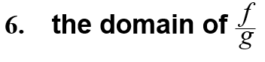
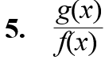

Let f(x) = 5x – 3and g(x) = –x² + 2. Find the following.
9. You have a $25 gift certificate for a book store. The store is offering 10% off all books. When should you use the certificate, before or after the 10% discount?

7. g( f (–2)) 8. f(g(x))

