Algebra 2 w/ Trig
3.4 Use Inverse Functions
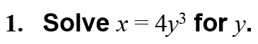
Warm-Up:

----------------------------------------------------------------NOTES---------------------------------------------------------------------------------------
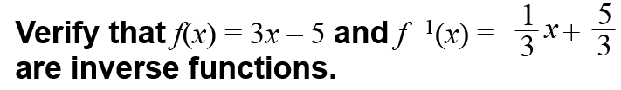
Example 1: Find an Inverse Relation Example 2: Verify that functions are inverses
Find an equation for the inverse of the relation y = 3x – 5.

YOU TRY:
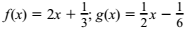
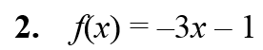
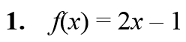
Find an equation for the inverse of the relation : Verify that the following functions are inverses:
3.

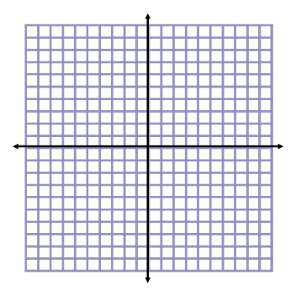
Example 3: Graphing a Function and it’s Inverse
Find the inverse of f(x) = x², x ≥ 0. Then graph f and f ^{–1}.

Example 4: Find the Inverse of a Cubic Function
Consider the function f (x) = 2x³ + 1. Determine whether the inverse of f is a function. Then find the inverse.

YOU TRY:
Find the inverse of the function. Then graph the function and its inverse.
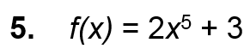
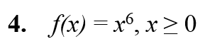

3.5 Graphing Square root and Cube Root Functions
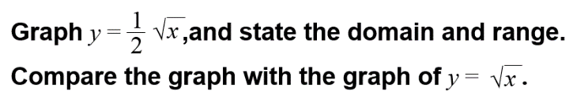
Example 1: Graph a Square Root Function Example 2: Graph a Cube Root Function

YOU TRY:
Graph the function. Then state the domain and range.
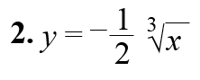
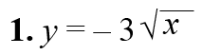

Example 3: Graph a Translated Square Root Function Example 4: Graph a Translated Cube Root Function

YOU TRY:
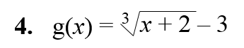
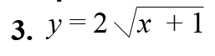
Graph the function. Then state the domain and range.

Hw: Section 3.5 p. 201 #3-24 all

