Notes – College Algebra
Section 3.6 – Compound Inequalities
Objective: To solve and graph inequalities containing the words ‘and’ / ‘or’

Do Now: Solve the inequalities

- $3\left(x-5\right)+9x≥-3$

- $3m-4≤6m+11$

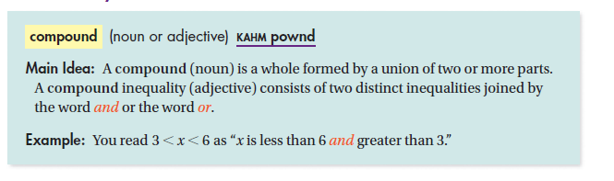

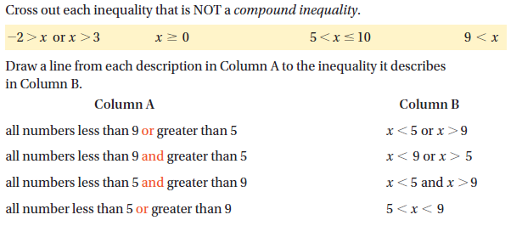

Ex: All real numbers that are greater than -2 and less than 6.

Ex: All real numbers that are less than 0 or greater than or equal to 5.

Ex: What are the solutions of $-3≤x-4<-1$? Graph the solutions.

Ex: What are the solutions of $7<x+6≤12$? Graph the solutions.

Ex: What are the solutions of $3t+2<-7 or-4t+5<1$

Ex: What are the solutions of $12h-3≥15h or 5>-0.2h+10$

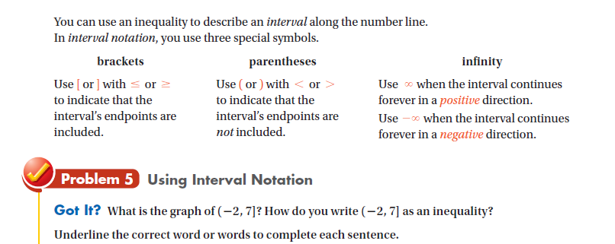

Ex: What is the graph of [-4, 6)? How do you write [-4, 6) as an inequality?

Ex: What is the graph of x$≤$-1 or x > 2? How do you write x$≤$-1 or x > 2 in interval notation?

HW: Section 3.6 p. 204 #12-34

