Algebra 2 w/ Trig

3.6 Solving Radical Equations

Warm-Up:

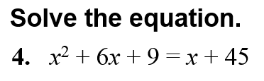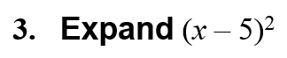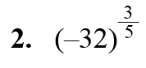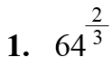**Evaluate the expression.**

-----------------------------------------------------------------NOTES--------------------------------------------------------------------------------------

Example 1: Solve a Radical Equation



YOU TRY:

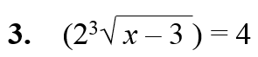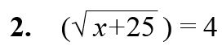**Solve equation. Check your solution.**

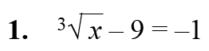

Example 2: Multiple Choice!!!!

Example 3: Solve an Equation with a Rational Exponent

YOU TRY:

**Solve the equation. Check your solution.**

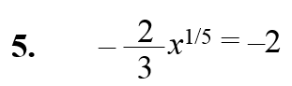

**Solve the equation. Check your solution.**



Example 4: Solve an Equation with an Extraneous Solution



Example 5: Solve an Equation with Two Radicals



YOU TRY:

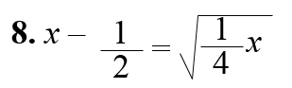**Solve the equation. Check for extraneous solutions**

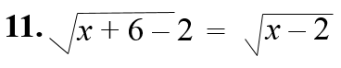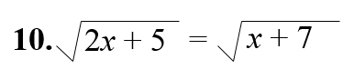

Hw: Section 3.6 p. 208 #3-21 all, 23-41 odd, 45-49 odd