3.7 Absolute Value Equations and Inequalities
Objective: To solve equations involving absolute value
To solve inequalities involving absolute value.

STARTER:
Solve and Graph; then write solution in Interval Notation:

Recall: l 2 l = 2 and l -2 l = 2

Key concept:
To solve both absolute value equations and inequalities you must first __________________________________.
Then write an _________________________ of linear equations or inequalities.
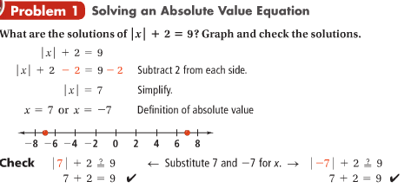

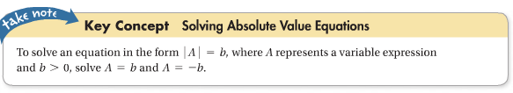
You try:
- l 2x – 5 l = 13 b. 3 l x – 2 l = 6

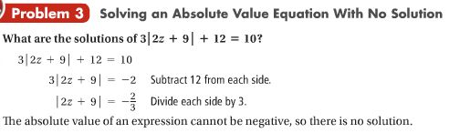

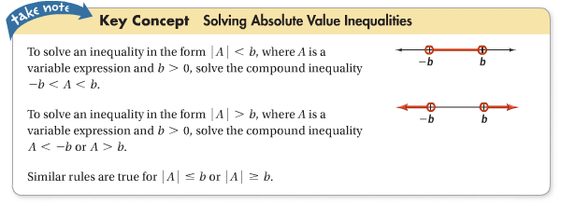
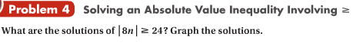

Now we will look at :

You try:

