**Find each union or intersection. Let *A =*** **{0, 2, 4, 6, 8}, *B =*{*x |*** ***x* is a positive even integer less than 12}, *C =*** **{1, 2, 4, 7}, and *D =*** **{–3, 2}.**

**1.** *A  B* **2.** *A ∩ C*

**3.** *A ∩ D* **4.** *B  C*

**5.** *B ∩ D* **6.** *C  D*

**7.** *A ∩ B ∩ C* **8.** *D  C  B*

**Draw a Venn diagram to represent the union and intersection of these sets.**

**9.** Let *A =* {a, b, c, d, e}, *B =* {a, b, c}, and *C =* {b, m, n, p}.

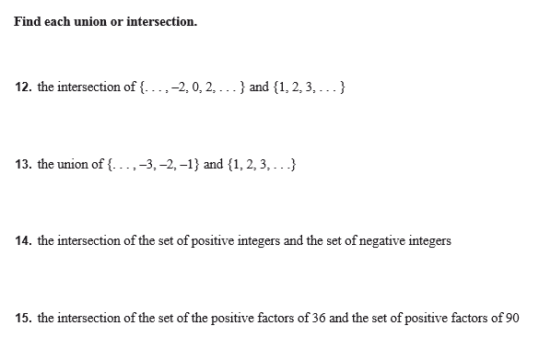**10.** Let *E =* {all negative even integers},  
*F =* {all negative integers greater than or equal to –10}, and *G =* {–4, –2, 0, 2, 4}.