Algebra 2 w/ Trig
4.1 Graph Exponential Growth Functions
Warm-Up:
- Course Evaluations
- Review Midyear
---------------------------------------------------------------------NOTES----------------------------------------------------------------------------------
Example 1: Graph $y=b^{x}$ for b > 1 Example 2: Graph $y={ab}^{x}$ for b > 1
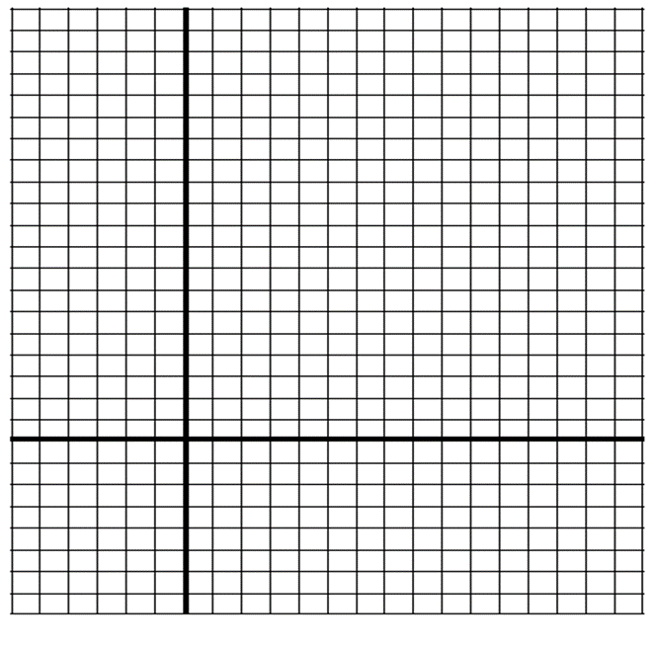
Graph $y=2^{x}$ a) Graph $y=\frac{1}{2}∙4^{x}$

b) Graph $y=-{\left(\frac{5}{2}\right)}^{x}$ Example 3: Graph $y={ab}^{x-h}+k$ for b > 1
Graph $y=4∙2^{x-1}-3$. State the domain and range.

You try:
- Graph $y=4^{x}$. State the domain and range. 2. Graph $y=\frac{2}{3}∙3^{x}$. State the domain and range.

3. Graph $y=3^{x+1}+2$. State the domain and range.

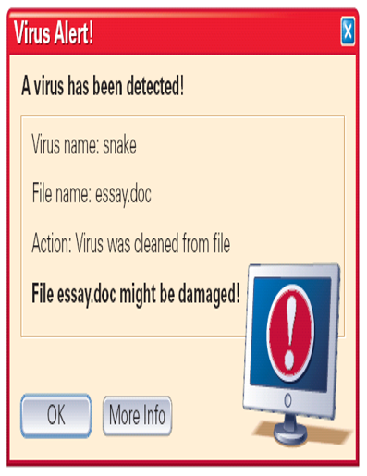
Example 4: Solve a multi-step problem
In 1996, there were 2573 computer viruses and other computer security incidents. During the next 7 years, the number of incidents increased by about 92% each year.
Write an exponential growth model giving the number n of incidents t years after 1996. About how many incidents were there in 2003?

You Try:
In the exponential growth model $y = 527{\left(1.39\right)}^{x}$ , identify the initial amount, the growth factor, and the percent increase.

Example 5: Find the balance in an account
You deposit $4000 in an account that pays 2.92% annual interest. Find the balance after 1 year if the interest is compounded with the given frequency.
- Quarterly b. Daily

YOU TRY:
5. You deposit $2000 in an account that pays 4% annual interest. Find the balance after 3 years if the interest is compounded daily.
a. With interest compounded daily, the balance after 3 years is:

KEEP GOING:
- Graph $y=\frac{3}{2}∙2^{x}$. State the domain and range. 2. Graph $y=3∙2^{x-2}-1$. State the domain and range.

3. You deposit $1500 in an account that pay 3% annual interest compounded daily. What is the balance in your account after 1 year?
Hw: Section 4.1 p. 232 #1-25 odds, 28-30 all, 37-38 all

