Notes - College Algebra 1
Section 4.2 – Patterns and Linear Functions
Objective(s): To identify and represent patterns and describe linear functions.

Starter:
Sketch a graph to represent the situation.
1. During a trip, your speed increases during the first hour and decreases over the next 2 hours.
2. The average temperature steadily decreases over the course of the football season.
3. The average test score of the class increased throughout the semester until it decreased slightly on the last test.
4. Error Analysis During the first 2 weeks of training, Shelly ran 15 miles per week. Then, she increased to 20 miles per week. Describe and correct the error in sketching a graph to represent the relationship between the weeks and the total number of miles she has run.
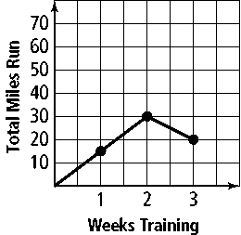

Section 4.2 – Patterns and Linear Functions
Objective(s): To identify and represent patterns and describe linear functions.
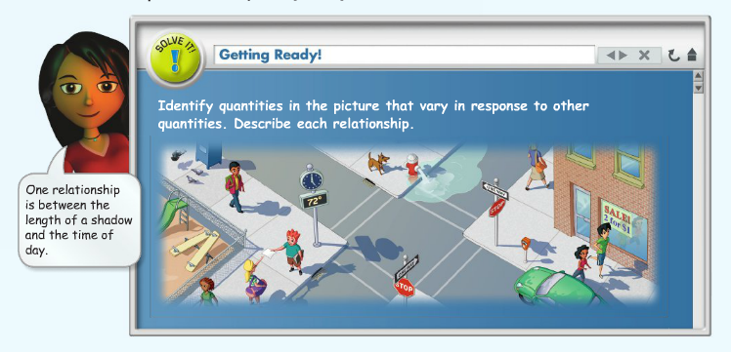

Dependent variable –

Independent variable –

Input –

Output -

Problem 1: In the diagram below, what is the relationship between the number of rectangles and the perimeter of the figure they form? Represent this relationship using a table, words, and equation and a graph

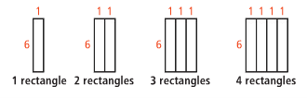
Step 1: Make a Table

Use x as the independent Variable and y as the independent variable.
Let x =

Let y =

Write each pair of input and output values x and y as an ordered pair (x, y)
- What pattern exists in the x-values of the table?
- What pattern exists in the y-values of the table?
- What pattern can you use to determine a y-value in the table if you are given an x-value?

Step 2: Look for a pattern in the table. Describe the pattern in words so you can write an equation to represent the relationship.

Words:

Equation:

Step 3: Use the table to make a graph.

Let’s Try it…
In the diagram below, what is the relationship between the number of triangles and the perimeter they form? Represent this relationship using a table, words, and equation and a graph.
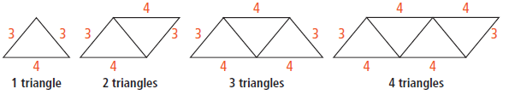

X =
Y =

Step1:

Step 2: Describe the pattern in words:

Write an equation:

Step 3: Use the table to make a graph

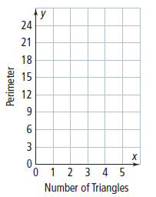

Function:
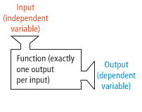
Linear Function:

Problem 2: Representing a Linear Function
Is the relationship in the table a linear function? Describe the relationship using words, an equation and a graph.

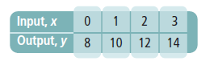

Describe the pattern:

Write an equation for the relationship:

Plot the points from the table on the graph.
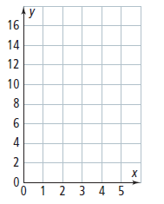

Underline the correct word or words to complete the sentence.
The points lie/do not lie on a line, so, the relationship is/is not a linear function.

Ex: Does the set of ordered pairs (0, 2), (1, 4), (3, 5) and (1, 8) represent a linear function.
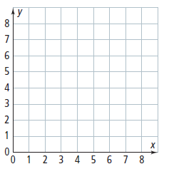

Do the ordered pairs represent a linear function? Explain.

Ex: Determine whether the relationship is a linear function. Then represent the relationship using words, an equation, and a graph.
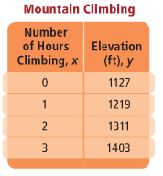

HW: Section 4.2 p. 243 #2, 5-10, 18, 19

