Name______________________________ Block______ Date___________
Quiz Review 4.2 - 4.6 Review
For each table, determine whether the relationship is a function. Then represent the relationship using an equation.
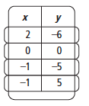
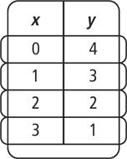
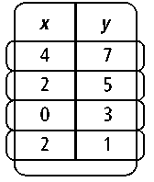
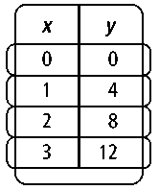
1. 2. 3. 4.

5. Tell whether the function below is linear or nonlinear. Explain.

Each set of ordered pairs represents a function. Write a rule that represents the function.
6. (0, 5), (1, 6), (2, 7), (3, 8), (4, 9) 7. (0, 0), (1, 1), (2, 4), (3, 9), (4, 16)

8. (0, 0), (1, 3), (2, 6), (3, 9), (4, 12) 9. (0, –8), (1, –7), (2, –6), (3, –5), (4, –4)

10. Writing Is the point on the graph of 6x – 2y = 18? How do you know?

11. What is the difference between a discrete and a continuous function? Explain.

Make a table of values for each function. Then graph each function rule. (MAKE X-Y AXIS)

12. y = –x + 3 | 13.

14. y = |x| + 3 | 15. y =–3x²
16. y = |x – 2| + 3 | 17. y = x² –2

18. $y=\left|x-2\right|$ 19. $y=x^{2}+1$

Identify the domain and range of each relation. Use a mapping diagram to determine whether the relation is a function.
20. {(–3, 6), (0, 2), (1, 0), (2, –3)} 21. {(–1, –4), (0, 0), (1, 4), (2, 8)}

Find the range of each function for the given domain.
22. f (x) = –2x + 1; {–2, 0, 2, 4, 6} 23. f (x) = x³ + 1; {–2, –1, 0, 1, 2}

Graph each function rule. Explain your choice of intervals on the axes of the graph. Tell whether the graph is continuous or discrete.
24. The cost d, in dollars, for a parking pass depends on the number of whole weeks w you purchase. This situation is represented by the function rule d = 25w.

For problems 25 – 31, Write a function rule that represents each situation, solve if necessary.
- The price p of an ice cream is $3.95 plus $0.85 for each topping t on the ice cream.
- A babysitter’s earnings e are a function of the number of hours n worked at a rate of $7.25 per hour.
- The price p of a club’s membership is $30 for an enrollment fee and $12 per week w to be a member.
- A plumber’s fees f are $75 for a house call and $60 per hour h for each hour worked.
- A hot dog d costs $1 more than one-half the cost of a hamburger h.
- José is 3 years younger than 3 times his brother’s age. Write a rule that represents José’s age j as a function of his brother’s age b. How old is José if his brother is 5?
- A taxicab charges $4.25 for the first mile and $1.50 for each additional mile. Write a rule for describing the total rate r as a function of the total miles m. What is the taxi rate for 12 miles?

- Does the data or graph represent a function? If so, is it discrete or continuous?
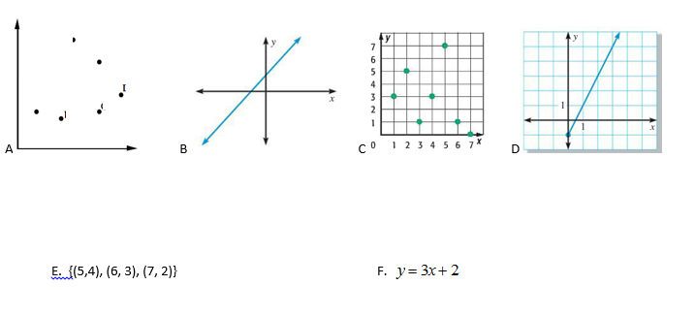
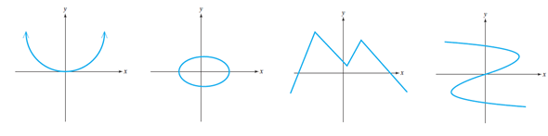
G. H. I. J.

