Algebra 2 w/ Trig
4.2 Graph Exponential Decay Functions
Warm-Up:
Evaluate the expression without using a calculator.
- ${\left(\frac{1}{3}\right)}^{-3}$ 2. $–{\left(\frac{2}{5}\right)}^{0}$ 3. $4{\left(\frac{2}{3}\right)}^{-2}+1$

4. A savings account pays 3% interest compounded monthly. What is the growth factor for this account?

-------------------------------------------------------------------NOTES------------------------------------------------------------------------------------
Example 1: Graph $y=b^{x}$ for 0 < b < 1 Example 2: Graph $y={a∙b}^{x}$ for 0 < b < 1
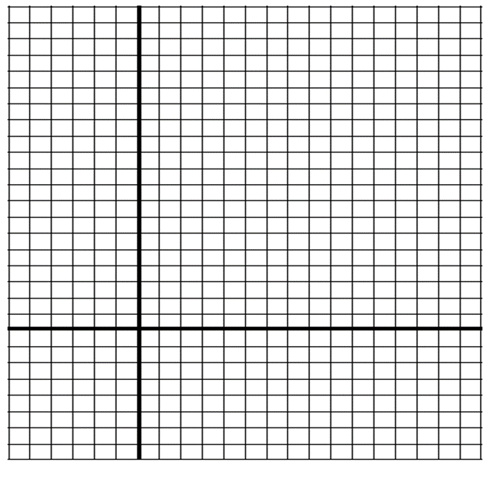
Graph $y={\left(\frac{1}{2}\right)}^{x}$. Graph $y=2{\left(\frac{1}{4}\right)}^{x}$.

YOU TRY:
- Graph $y={\left(\frac{2}{3}\right)}^{x}$ 2. Graph $y=-2{\left(\frac{3}{4}\right)}^{x}$

Example 3: Graph $y={a∙b}^{x-h}+k$ for 0 < b < 1 Example 4: Solve a multi-step problem
A new snowmobile costs $4200. The value of the snowmobile decreases by 10% each year.
Write an exponential decay model giving the snowmobile’s value y (in dollars) after t years. Estimate the value after 3 years.
Use the graph to estimate when the value of the snowmobile will be $2500.
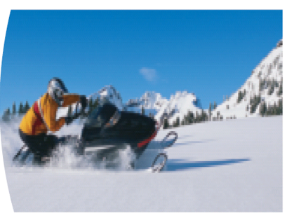
Graph $y=3{\left(\frac{1}{2}\right)}^{x+1}-2$

YOU TRY:
Graph the function. State the domain and range.
3. $y={\left(\frac{1}{4}\right)}^{x-1}+1$ 4. $y=5{\left(\frac{2}{3}\right)}^{x+1}-2$ 5. $g\left(x\right)=-3{\left(\frac{3}{4}\right)}^{x-5}+4$

6. The value of a snowmobile has been decreasing by 7% each year since it was new. After 3 years, the value is $3000. Find the original cost of the snowmobile.

KEEP GOING:
Graph the following, state the domain and range.
- $y=4{\left(\frac{1}{2}\right)}^{x}$ 2. $y=3{\left(\frac{1}{4}\right)}^{x+2}+2$

3. A new laptop computer costs $1500. The value of the computer decreases by 22% each other.
a. Estimate the value of the computer after 2 years.

b. Estimate when the computer will be worth $550.
Hw: Section 4.2 p. 239 #1-23 odds, 27, 31, 33

