College Algebra 1
Section 4.3 Patterns and Non-Linear Functions
Starter:
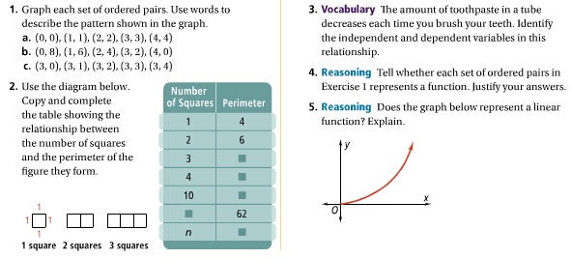

Notes:
A _______________________ is a function whose graph is not a line or part of a line.

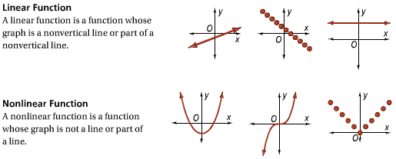

Classify the functions as linear or nonlinear:
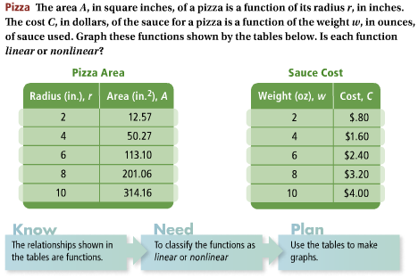

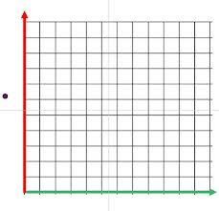
YOU TRY:
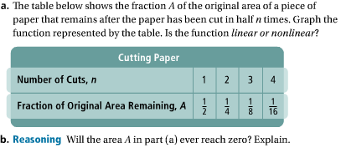

Representing Patterns and Nonlinear Functions:
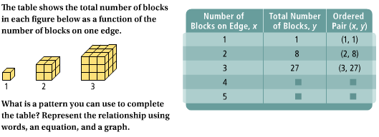
Words: Graph:

Equation:

YOU TRY:
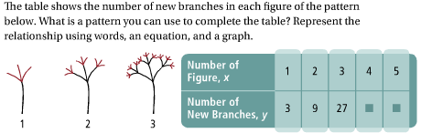

Writing a Rule to Describe a Nonlinear Function:
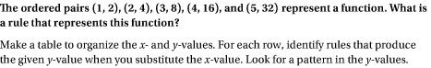

YOU TRY:

HW: 4.3 p. 249 1, 3-5, 8-16

