Algebra 2 w/ Trig
4.3 Use Functions Involving e
Warm-Up:
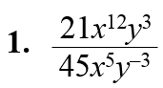
Simplify the expression.
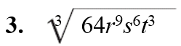
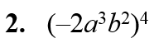

4. An account with a balance of $1000 pays 3.65% annual interest compounded daily. What is the balance at the end of 1 year if no money is added to the principal?

---------------------------------------------------------------------NOTES----------------------------------------------------------------------------------
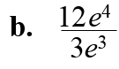
Example 1: Simplify Natural Base Expressions
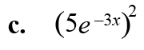
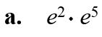

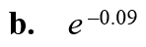
Example 2: Evaluate natural base expressions

YOU TRY:
Simplify the following expressions.
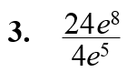
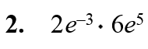
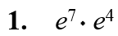

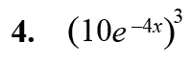

Example 3: Graph natural base functions
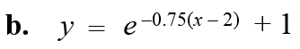
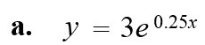
Graph the function. State the domain and range.

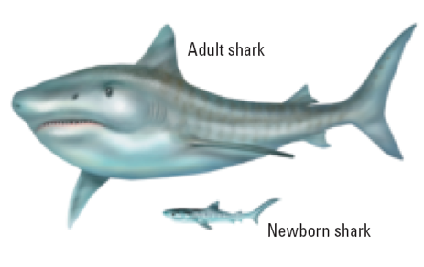
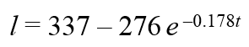
Example 4: Solve a Multi-Step Problem
The length l (in centimeters) of a tiger shark can be modeled by the function
where t is the shark’s age (in years). Use the graph to estimate the length of a tiger shark that is 3 years old.

YOU TRY:
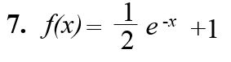
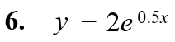
Graph the following. State the domain and range.

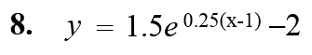

Example 5: Model Continuously Compounded Interest
You deposit $4000 in an account that pays 6% annual interest compounded continuously. What is the balance after 1 year?

YOU TRY:
9. FINANCE: You deposit $2500 in an account that pays 5% annual interest compounded continuously. Find the balance after each amount of time?
a. 2 years b. 5 years

10. FINANCE: Find the amount of interest earned in parts (a) – (c) of Exercise 9.
a. b.

KEEP GOING:
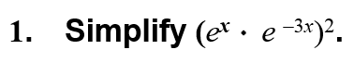

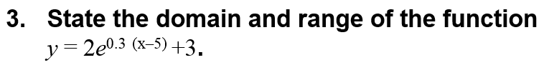

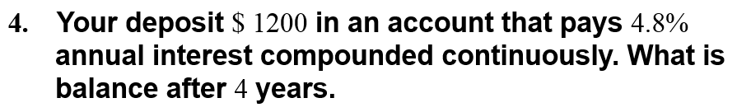
Hw: Section 4.3 p. 247 #3-47 odds

