College Algebra 1
4.4 Graphing a Function Rule
OBJ: To graph equations to represent functions.

Starter:
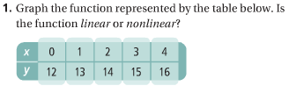
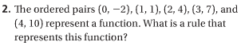
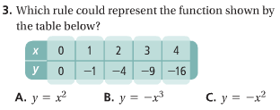
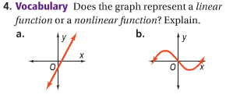
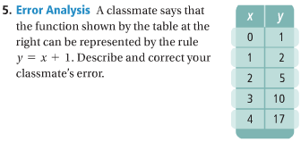

Notes:
The set of all solutions of an equation forms the equation’s graph.
In other words: The graph shows all values that will make the equation true.
Graphing a Function Rule:
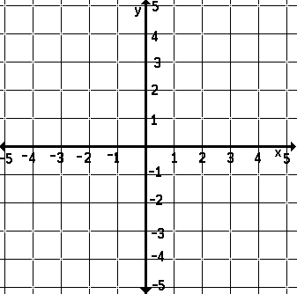

You Try!!

When you graph a real world function rule, choose appropriate intervals for the units on the axes.

Graphing a Real World Function Rule:
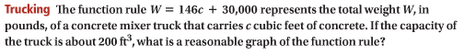
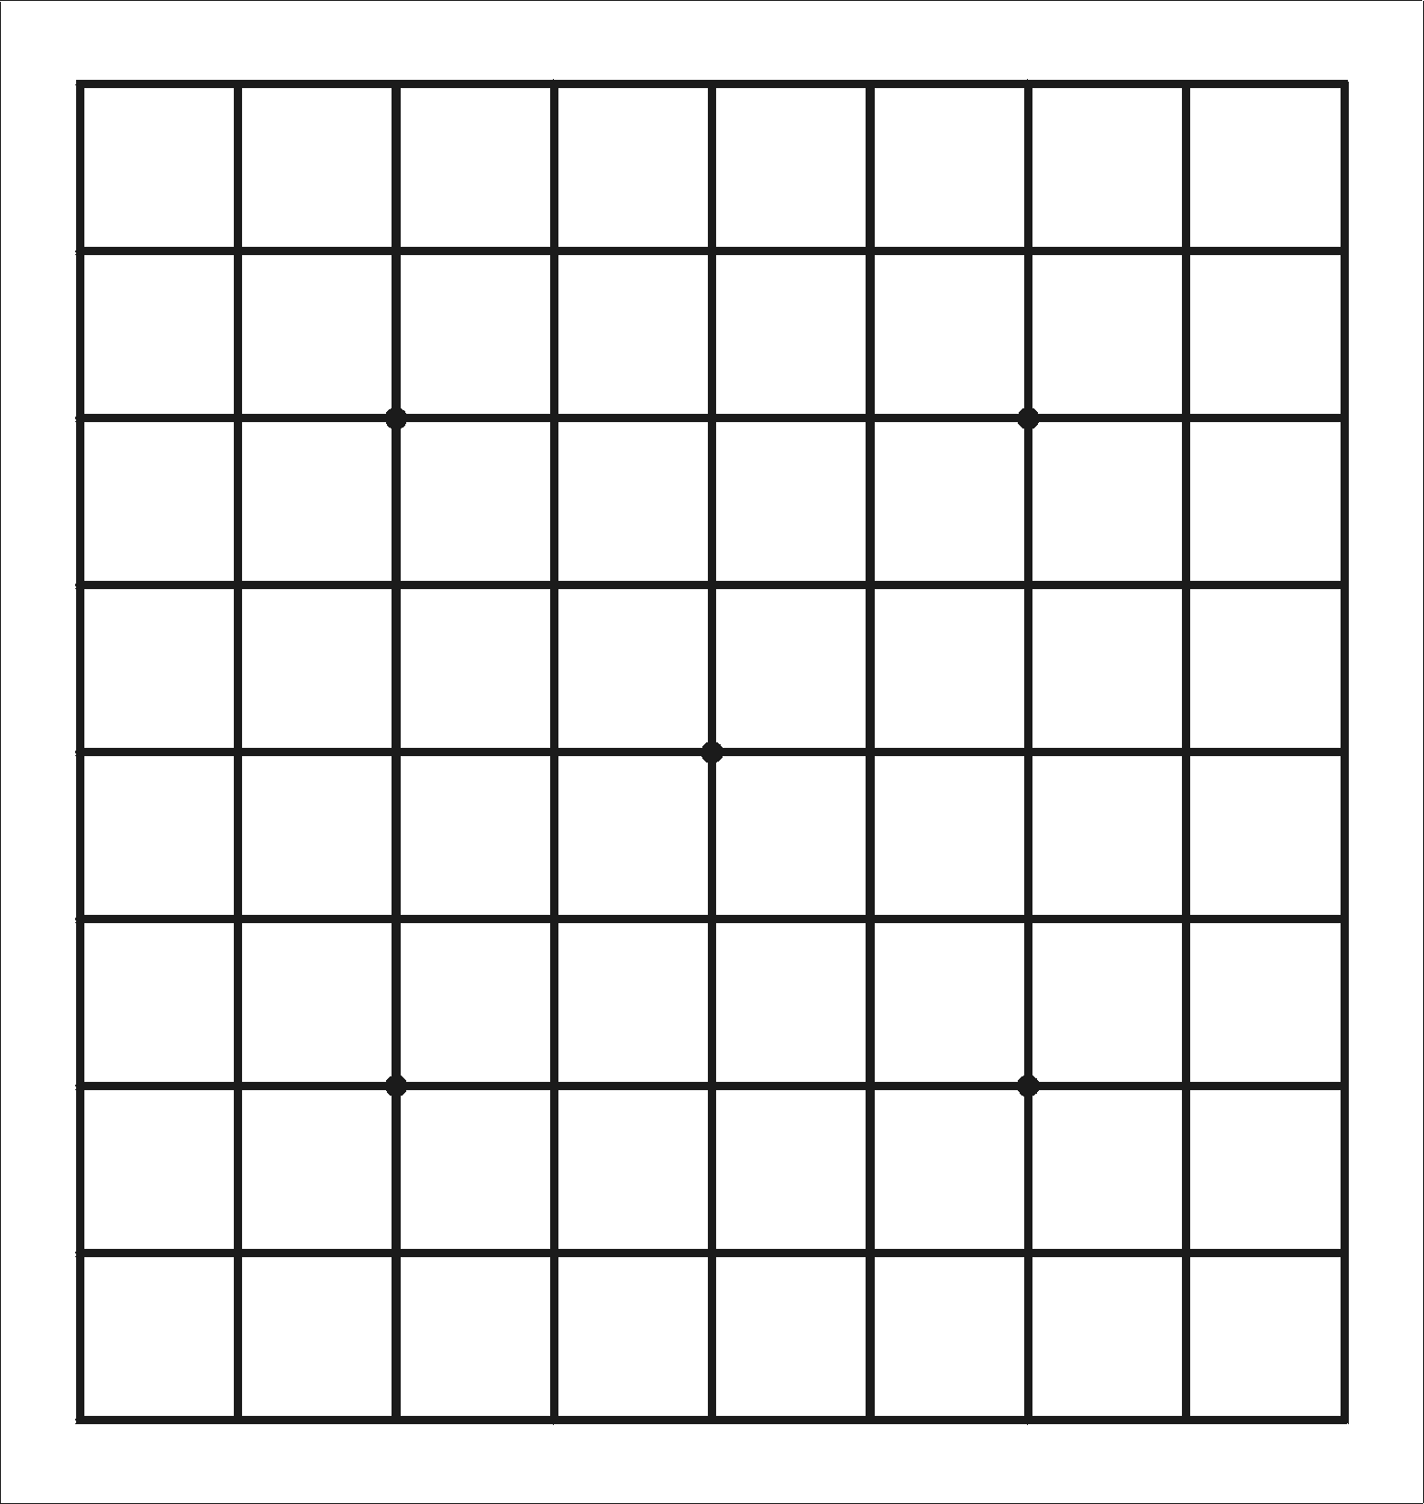

You Try:
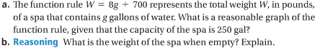
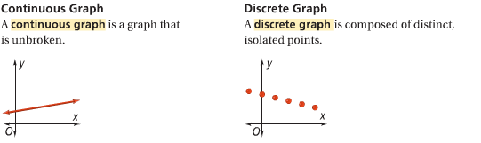

Identifying Continuous and Discrete Graphs:
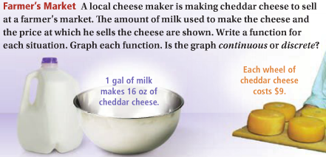

You Try:
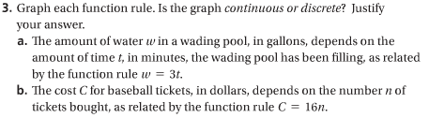

Graphing a Nonlinear Function Rule:
What is the graph of each function?

You Try:

Hw: Section 4.4 p. 257 #9-11, 21-23, 25-29, 33, 37, 40

