Algebra 2 w/ Trig
4.4 Evaluate Logarithms and Graph Logarithmic Functions
Warm-Up:
- Find the inverse of the function y = 3x – 5.

2. An account that pays 3% annual interest compounded continuously has a balance of $10,000 on June 1, 2008.
If no money is added, what is the balance on June 1, 2010?

---------------------------------------------------------------NOTES----------------------------------------------------------------------------------------
Example 1: Rewrite Logarithmic Equations YOU TRY: Rewrite the equation in exponential form.
Logarithmic Form Exponential Form Logarithmic Form Exponential Form
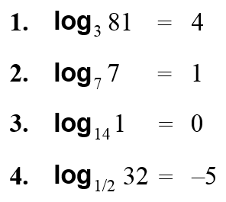
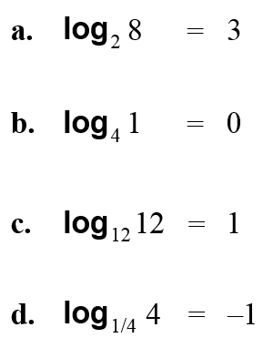

Example 2: Evaluate Logarithms
Evaluate the logarithm.
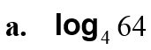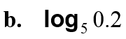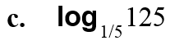

Example 3: Evaluate Common and Natural Logarithms
Expression Keystrokes Display Check
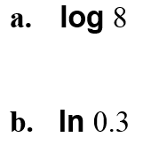
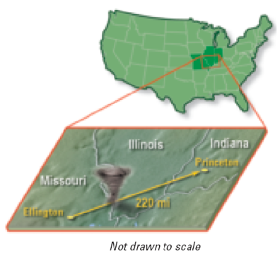
Example 4: Evaluate a Logarithmic Model
The wind speed s (in miles per hour) near the center of a tornado can be modeled by
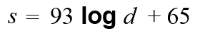
where d is the distance (in miles) that the tornado travels. In 1925, a tornado traveled 220 miles through three states. Estimate the wind speed near the tornado’s center.

YOU TRY:
Evaluate the logarithm. By hand!
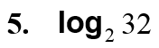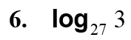

Expression Display Check
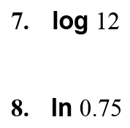

9. WHAT IF? Use the function in Example 4 to estimate the wind speed near a tornado’s center if its path is 150 miles long.

Example 5: Use Inverse Properties
Simplify the expression.

YOU TRY:
Simplify the expression.
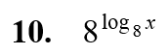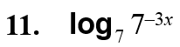

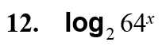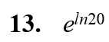

Hw: Section 4.4 p. 255 #3-6, 8-36 even
4.4 Day 2
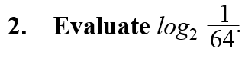
Warm-Up:

--------------------------------------------------------------NOTES-----------------------------------------------------------------------------------------
Example 6: Find Inverse Functions
Find the inverse of the function.

YOU TRY:

Example 7: Graph Logarithmic Functions
Graph the function.
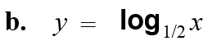

Example 8: Translate a Logarithmic Graph

YOU TRY:
Graph the function. State the domain and range.
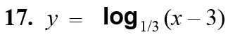

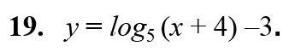
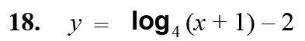

KEEP GOING
Evaluate the logarithm without using a calculator.
- log₁₀ 100

- log₈ 64

- log₃ 9

- log₇ 7

- log₂ 8

- log₄ 64
Hw: Section 4.4 p. 255 #37-57 odd (Use graph paper)

