Notes – College Algebra
Section 4.5- Writing a Function Rule
Objective: To write equations that represent functions.

Starter:
- Graph the function rule $y=3x-2$

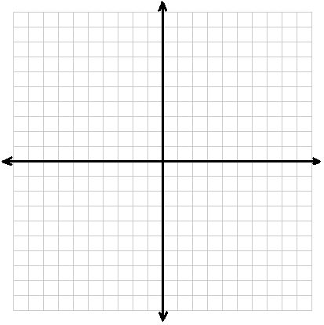

- Graph the function rule $y=x^{3}-1$

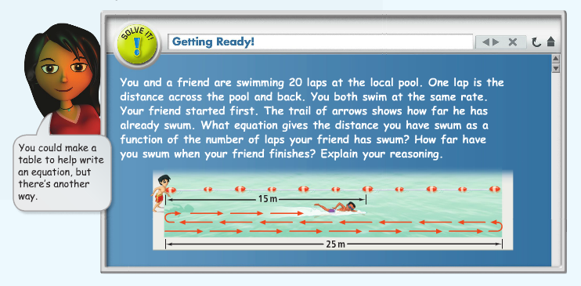

Problem 1: Writing a Function Rule

You can estimate the temperature by counting the number of chirps of the snowy tree cricket. The outdoor temperature is about 40˚F more than one fourth the number of chirps the cricket makes in one minute. What is a function Rule that represents this situation?

Problem 2: Writing and Evaluating a Function Rule

A concert seating plan is shown below. Reserved seating is sold out. Total revenue from ticket sales will depend on the number of general-seating tickets sold. Write a function rule to represent this situation. What is the maximum possible total revenue?

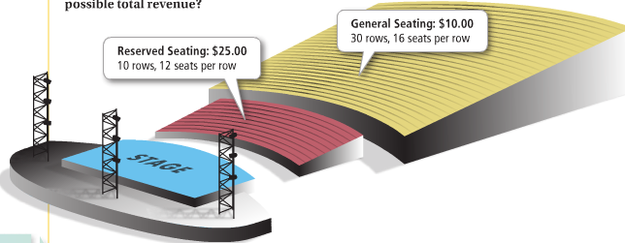

Try these…

- A landfill has 50,000 tons of waste in it. Each month it accumulates an average of 420 more tons of waste. What is a function rule that represents the total amount of waste after m months?

- A kennel charges $15 per day to board dogs. Upon arrival, each dog must have a flea bath that costs $12. Write a function rule for the total cost for n days of boarding plus a bath. How much does a 10 day stay cost?

Problem 3: Writing a Nonlinear Function Rule

HW: Section 4.5 p. 265 #9-25 odd

