Algebra 2 w/ Trig

4.5 Apply Properties of Logarithms

Warm-Up:

Evaluate the logarithm.



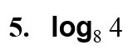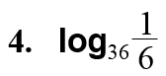



----------------------------------------------------------------NOTES---------------------------------------------------------------------------------------

Example 1: Use Properties of Logarithms

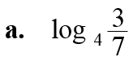

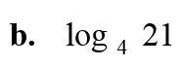

YOU TRY:

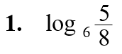

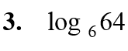



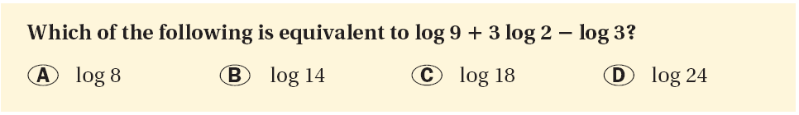Example 2: Expand a Logarithmic Expression Example 3: Condensing Logarithmic Expressions

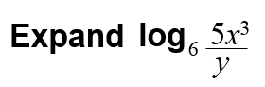

YOU TRY:



Hw: Section 4.5 p. 262 #3-29 odd, Fill out Matho board

4.5 Day 2!

Warm-Up:





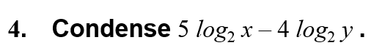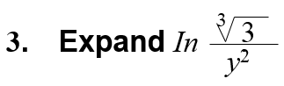

----------------------------------------------------------------NOTES---------------------------------------------------------------------------------------

Example 4: Use the Change of Base Formula



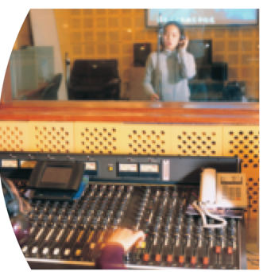Example 5: Use Properties of Logarithms in Real Life

**For a sound with intensity** *I* **(in watts per square meter), the loudness** *L*(*I*) **of the sound (in decibels) is given by the function**

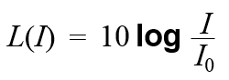

**where $I_{0 }$ is the intensity of a barely audible sound (about $10^{-12}$ watts per square meter). An artist in a recording studio turns up the volume of a track so that the sound’s intensity doubles. By how many decibels does the loudness increase?**

YOU TRY:

KEEP GOING:

**Use** *log*5 201.861 **and** *log*5 81.292 **to evaluate the logarithm.**

1. **Use the change-of- base formula to evaluate** *log*4 50**.**
2. **The intensity level of an electric guitar is** 102.8**watts per square meter. Use the formula**

*L* (*I*)=10*log $\frac{I}{I_{0}}$* **where** *I*010–12 **watts per square meter, to find the decibel level of the guitar.**

**Use the change-of-base formula to evaluate the logarithm.**





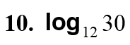

**11. WHAT IF? In Example** 5**, suppose the artist turns up the volume**

**so that the sound’s intensity triples. By how many decibels does the**

**loudness increase?**

Hw: Section 4.5 p. 262 #31-61 odd