Notes – College Algebra
Section 4.6-Formalizing Relations and Functions
Objective(s): To determine whether a relation is a function.
To find domain and range and use function notation.

Warm Up:
1. The school cafeteria has 285 cartons of juice in stock. Each day, a total of 60 cartons are sold. What equation is a function rule that represents this situation?

2. A plumber charges a service fee o $40 plus $25 per hour for labor. Write a function rule for the total cost of hiring the plumber for a job that takes x hours. How much would it cost to hire the plumber for a job that takes 4 hours?

3. Write a function rule for the area of a triangle whose base is 4ft more than the height. What is the area of the triangle when its height is 6ft?

- Domain =

- Range =

- Relation =

Example 1
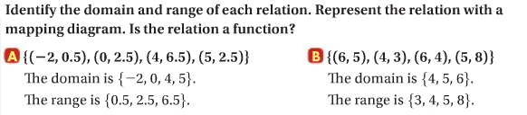

- Vertical Line Test =

Example 2
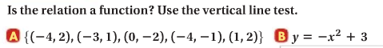
x
y
x
y

- Function Notation =

Example 3

Example 4

Example 5
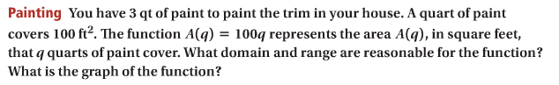

You try!
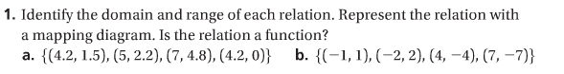

x
y
x
y

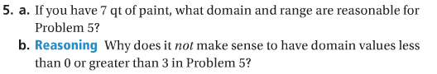
HW: Section 4.6 p. 271 #9-23

