Algebra 2 w/ Trig
4.6 Solve Exponential and Logarithmic Equations
Warm-Up:
- Write log₃(2x – 7) = 4 in exponential form. 2. Write 8^{x} = 30 in logarithmic form.

Solve the equation.
3. 100^{x} = 1000 4. log₅x = –3

--------------------------------------------------------------NOTES-----------------------------------------------------------------------------------------
Example 1: Solve by Equating Exponents YOU TRY: Solve the equation.
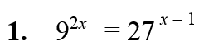
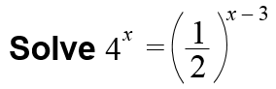

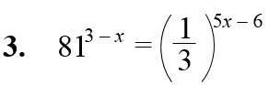
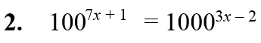

Example 2: Take a Logarithm of Each Side
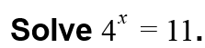

Example 3: Use an exponential Model
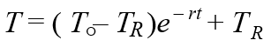
You are driving on a hot day when your car overheats and stops running. It overheats at 280°F and can be driven again at 230°F. If r = 0.0048 and it is 80°F outside, how long (in minutes) do you have to wait until you can continue driving?
Newton’s Law of Cooling:

YOU TRY: Solve the equation.
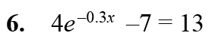
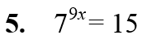
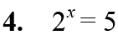

Example 4: Solve a Logarithmic Equation Example 5: Exponentiate Each Side of an Equation
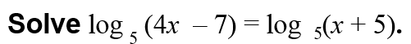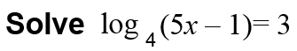

Example 6: Multiple Choice!!!
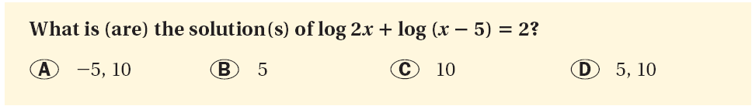

YOU TRY: Solve the equation. Check for extraneous solutions.
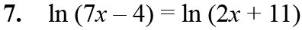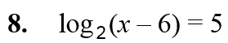

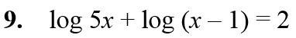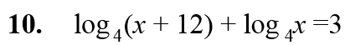

Example 7: Use a Logarithmic Model
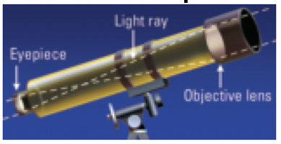
The apparent magnitude of a star is a measure of the brightness of the star as it appears to observers on Earth. The apparent magnitude M of the dimmest star that can be seen with a telescope is given by the function
M = 5 log D + 2
where D is the diameter (in millimeters) of the telescope’s objective lens. If a telescope can reveal stars with a magnitude of 12, what is the diameter of its objective lens?

YOU TRY:
WHAT IF? Use the information from Example 7 to find the diameter of the objective lens of a telescope that can reveal stars with a magnitude of 7.

KEEP GOING:
Solve the equation.
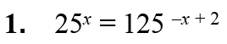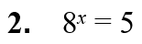

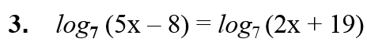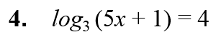

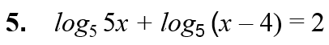
Hw: Section 4.6 p. 271 #25-45 odd

