College Algebra 1
4.7 Sequences and Functions
Objective: To identify and extend patterns in sequences
To represent arithmetic sequences using function notation

Starter:
- What is the domain and range of the relation? {(-1,2)(-3,6)(0,-4)(3,-4)(5,4)}

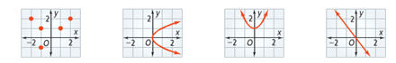
- Use the vertical line test to determine whether the relation is a function.

- Come up with a relation of at least 4 coordinate points that is not a function.

Vocabulary:
- A __________________ is an ordered list of numbers that often form a pattern.
- Each number in the list is known as a ______________________________.

Extending a Sequence: First determine the pattern of the terms listed, and use that pattern to further extend the sequence.

Hw: Section 4.7 p. 27 #9-17, 30-35 (write explicit equation as well)

In an ____________________________ the difference between consecutive terms is constant.
The difference is called the _______________________________.

Make a table of the bids. Identify the common difference.

Use the rule for an arithmetic sequence and write a rule for the online auction. Then using that rule, find the value of the 12th bid.

